- Create VPC with 2 private and 2 public subnets.
- Login to aws console.
- Search for VPC service and enter VPC dashboard.
- Click on create VPC.
- Select VPC and more.
- Name tag: VPC-Daily-Task
- IPv4: 10.0.0.0/16
- IPv6: none
- Tenancy: default
- No. of availability zones: 2
- No. of public subnets: 2
- No. of private subnets: 2
- Nat gateway: none
- VPC endpoints: none
- Click on create VPC.
- After VPC is created, click on view VPC.

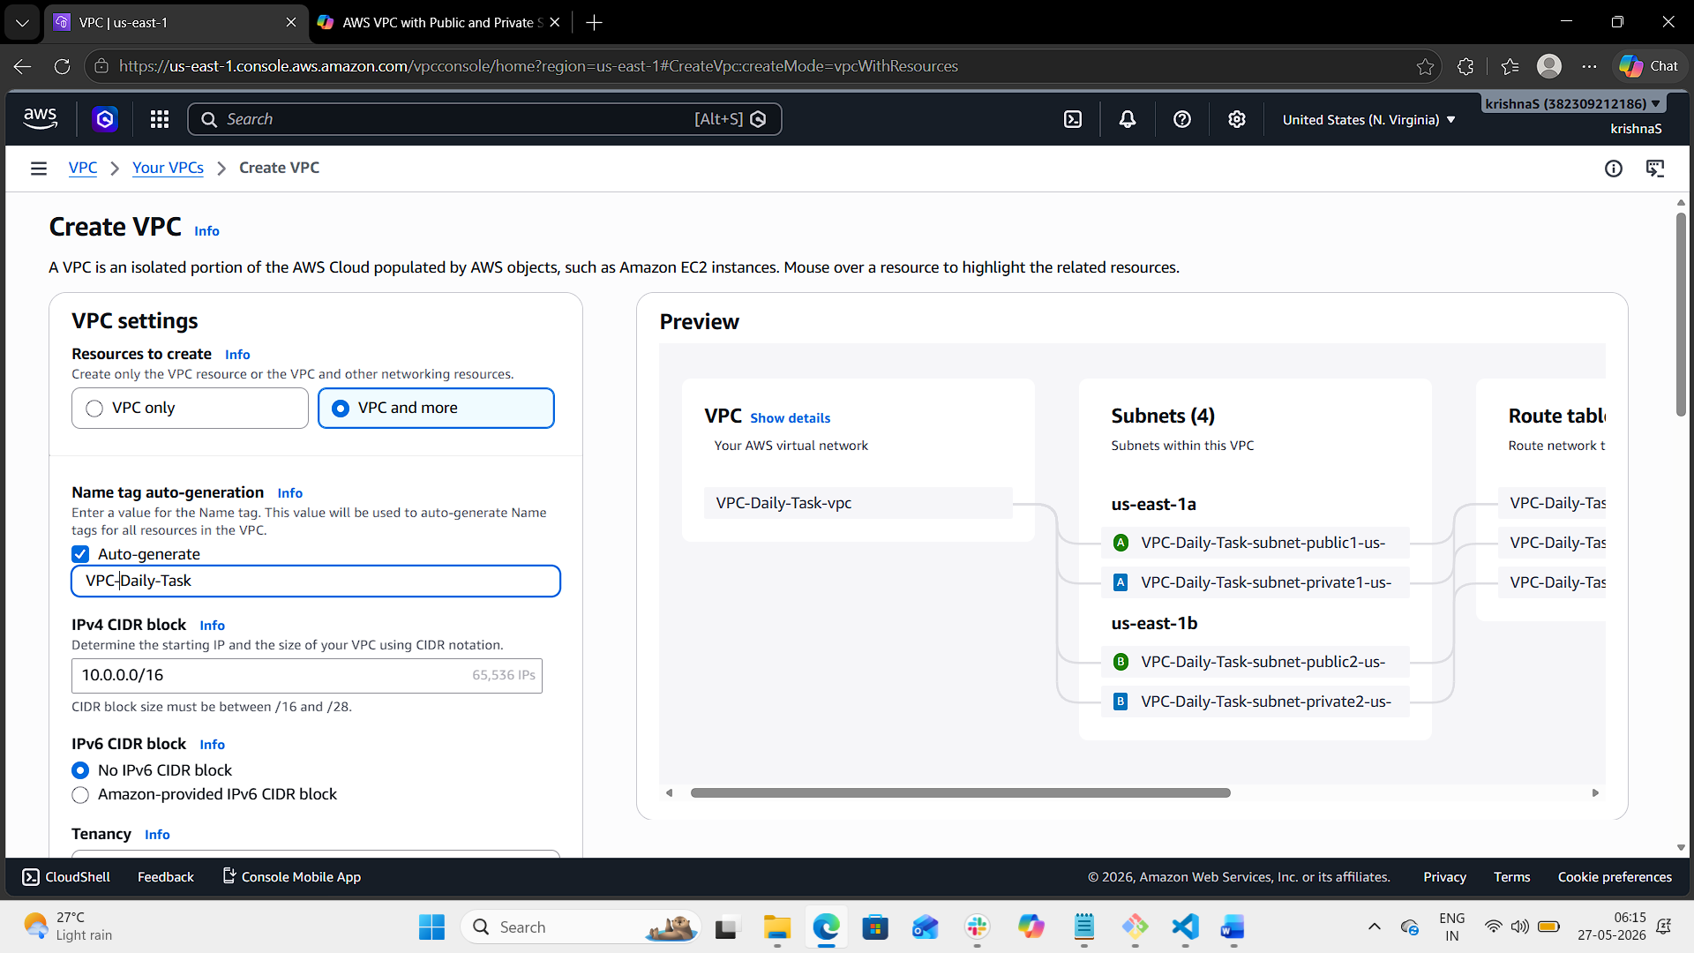
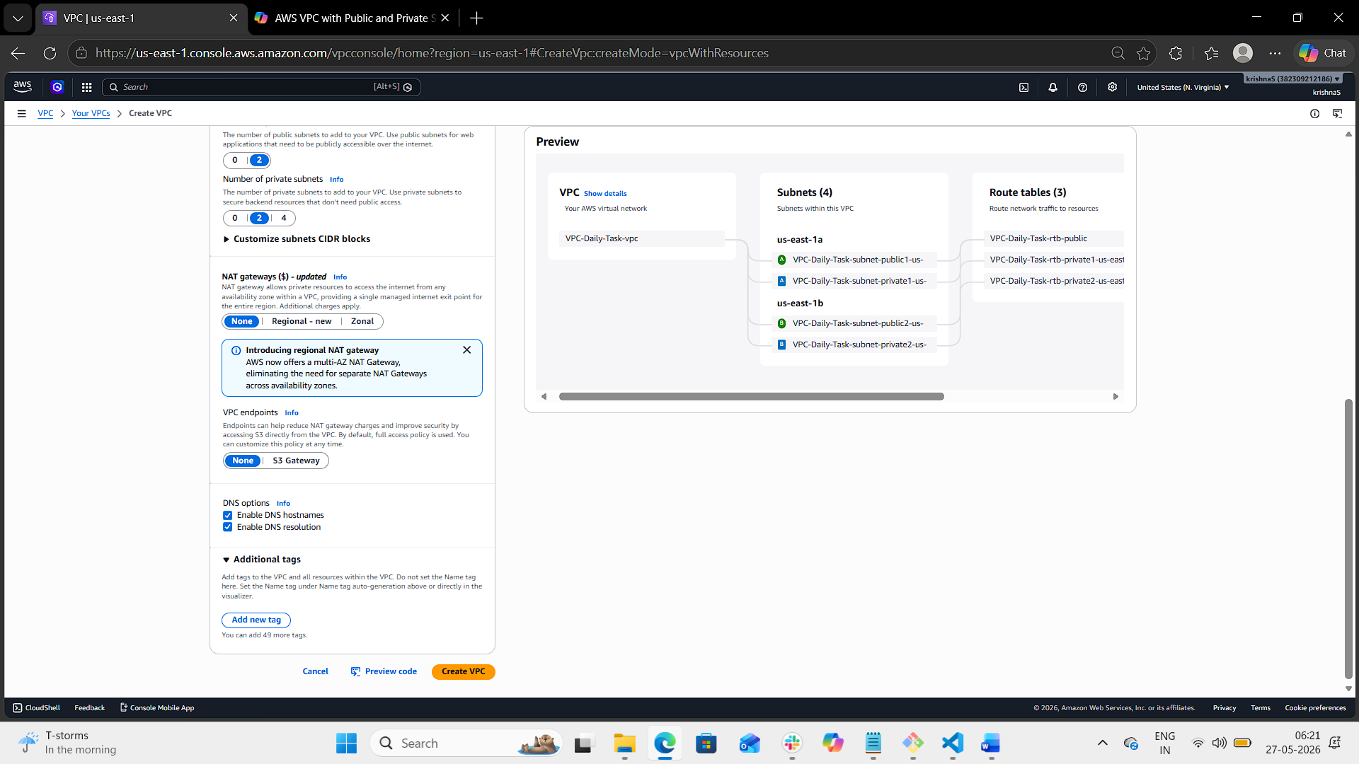
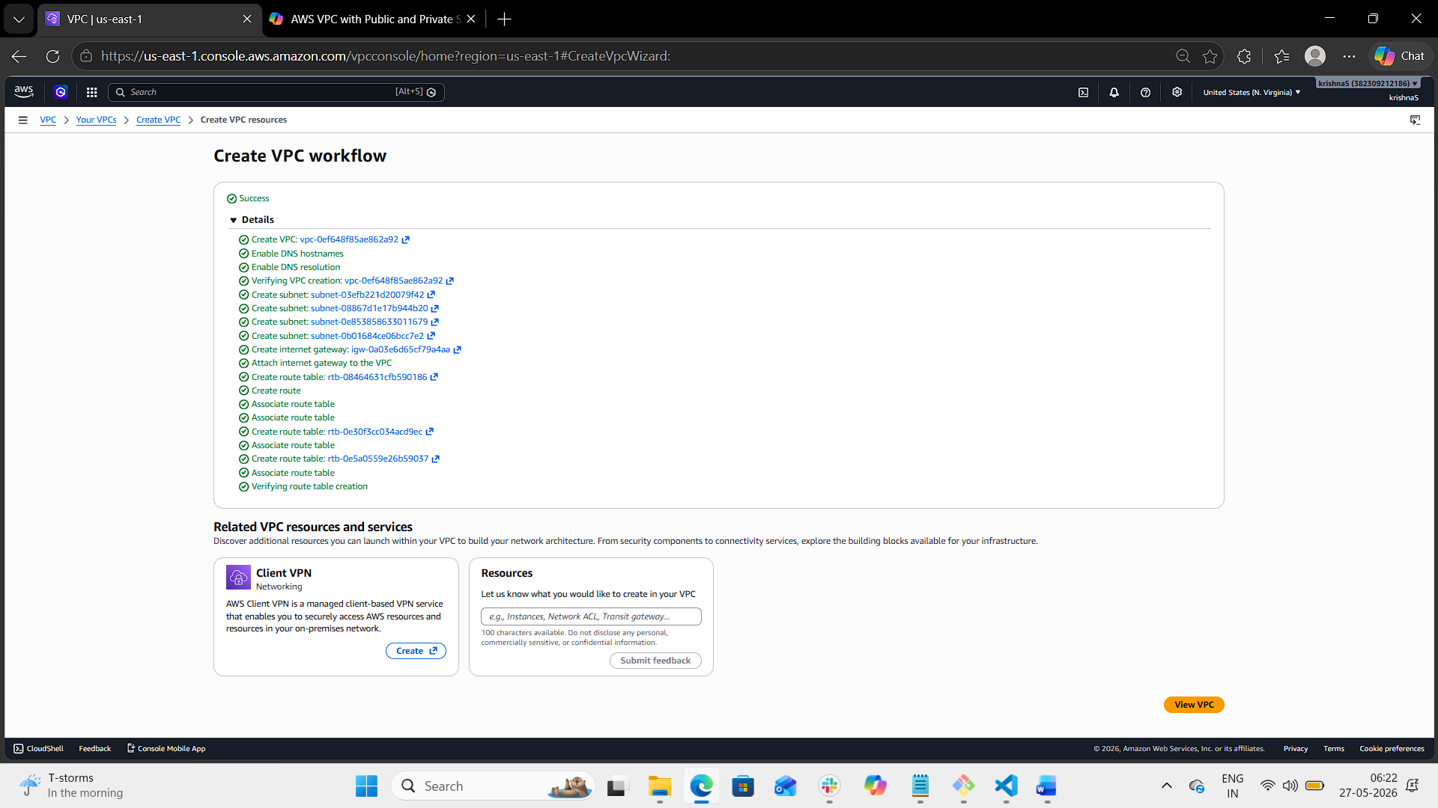
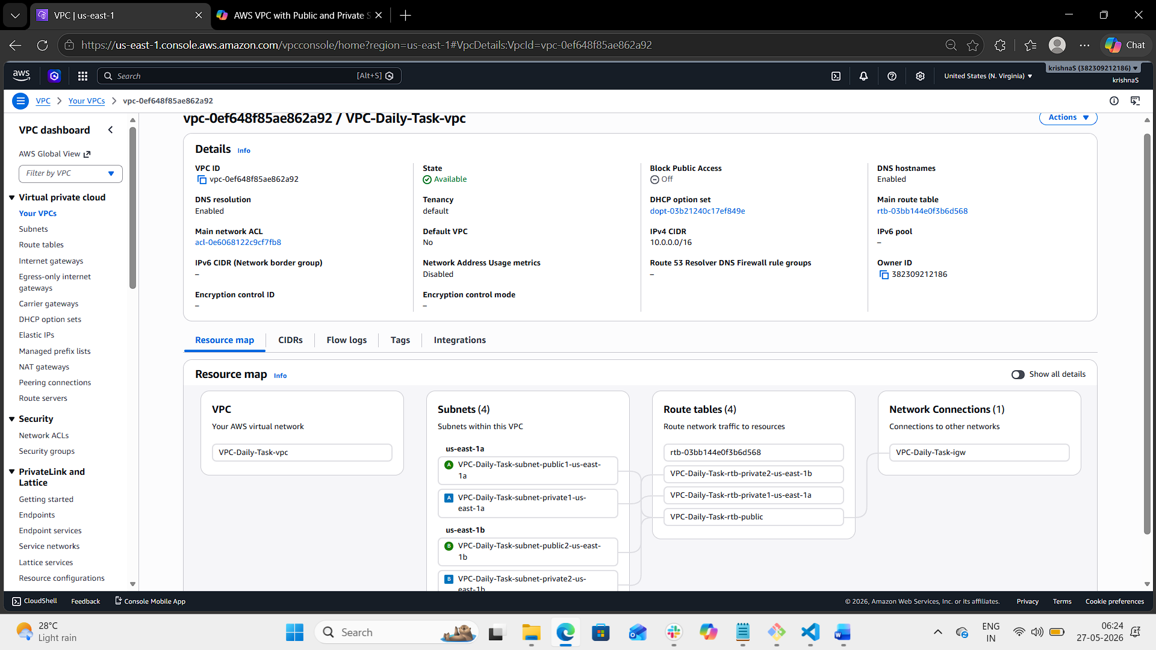
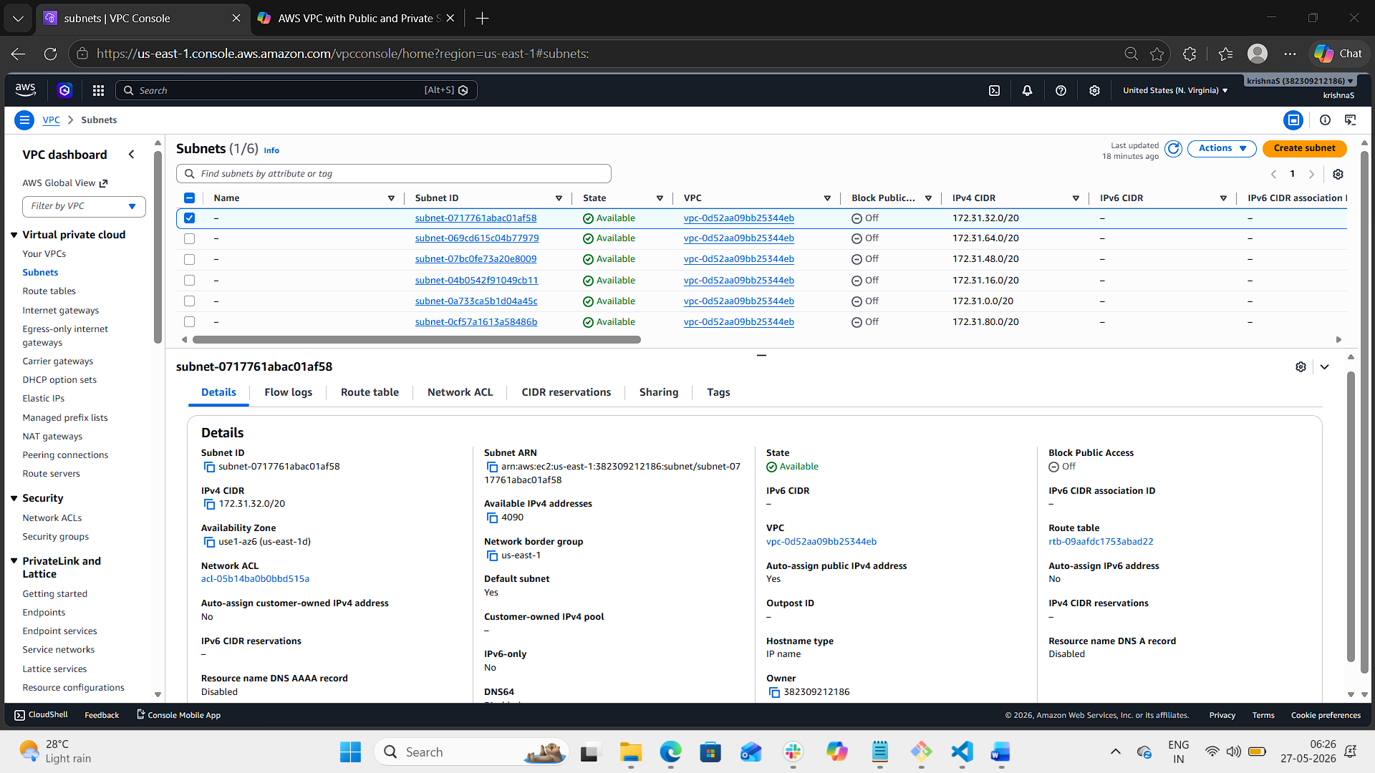
- Enable DNS Hostname in VPC.
- Login to aws console.
- Enter VPC dashboard.
- Click on your VPC.
- Select edit VPC settings under action drop down.
- Make sure that the DNS resolution and hostnames are enabled.
- Click on save button.

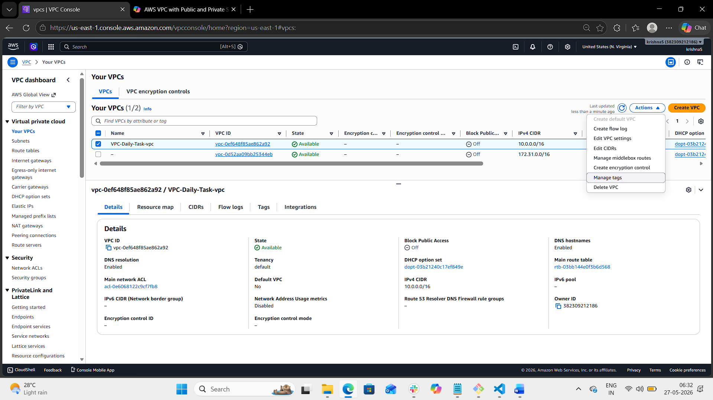
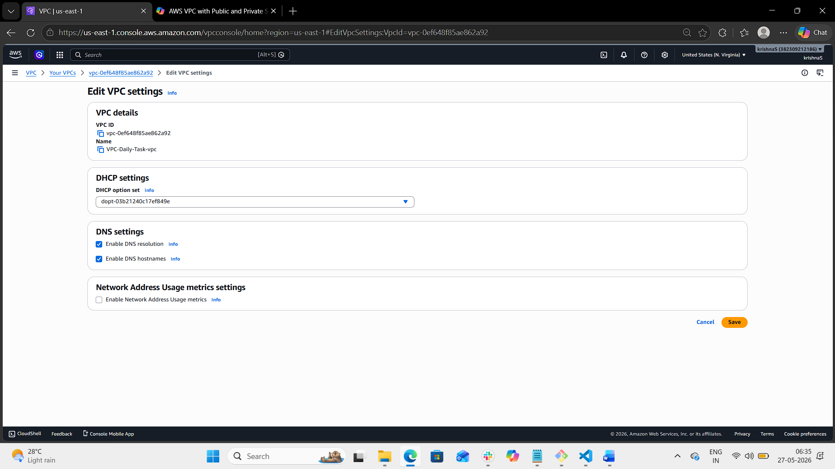
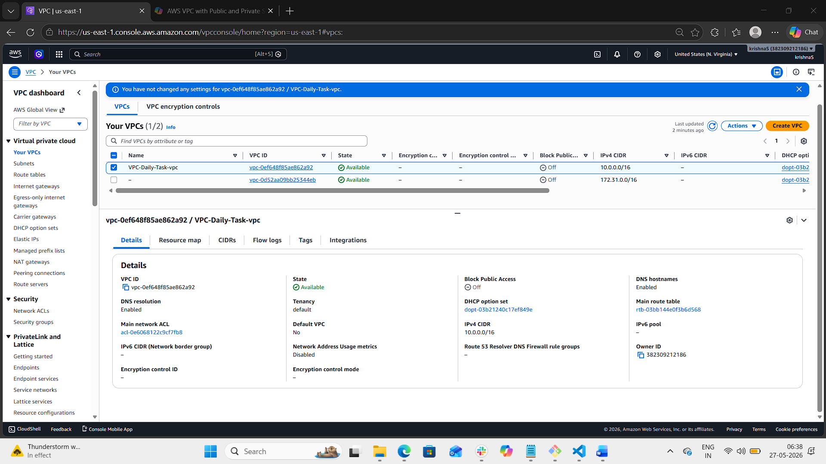
- Enable Auto Assign Public IP in 2 public subnets.
- Login to aws console.
- Enter VPC dashboard.
- Navigate to subnet page.
- Select VPC-Daily-Task-subnet-public1-us-east-1a
- Click on action and select edit subnets settings option.
- Under auto-assign IP settings: Enable auto-assign public IPv4 address.
- Click on save.
- Now do the same with VPC-Daily-Task-subnet-public2-us-east-1b to enable auto-assign public IP address.
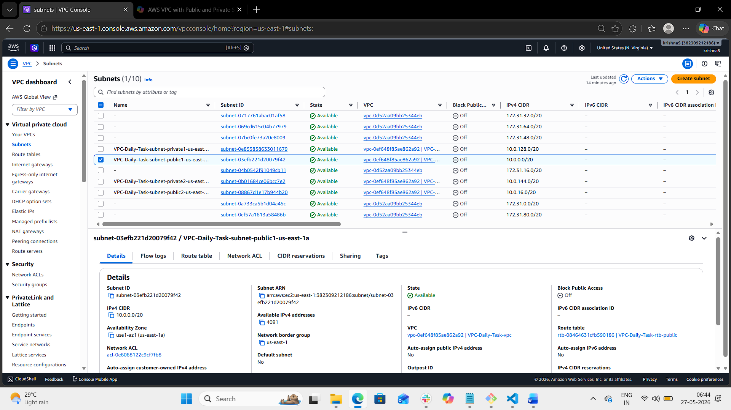
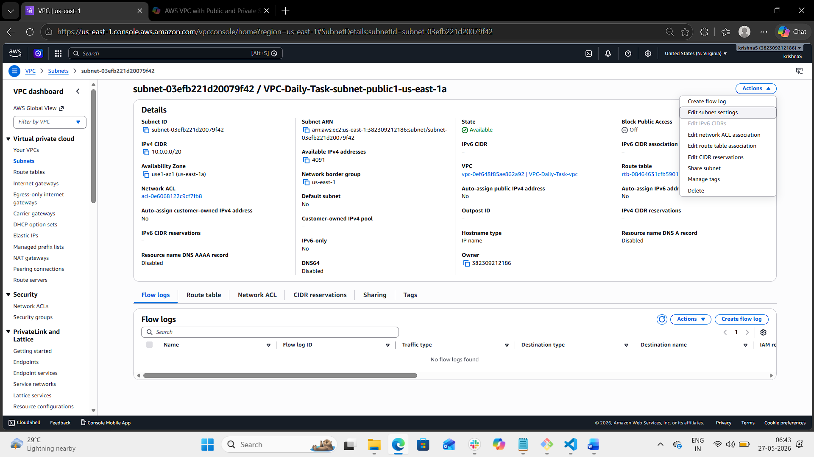
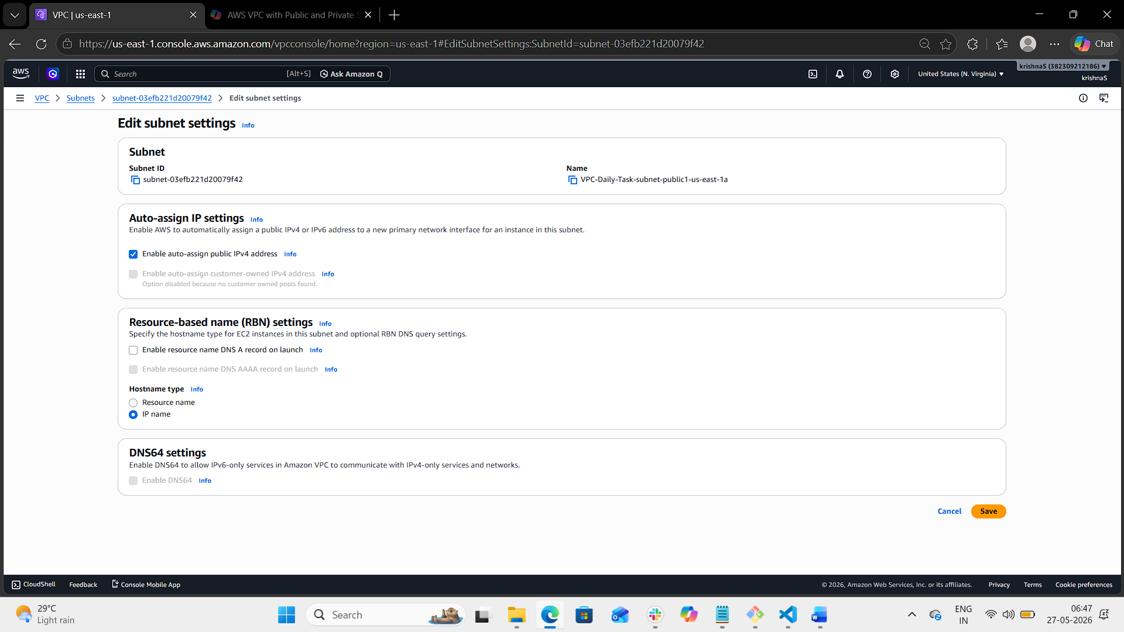
- Add 2 private subnets in private route table.
- Login to aws console.
- Enter VPC dashboard.
- Navigate to route tables page.
- Select VPC-Daily-Task-rtb-private1-us-east-1a
- Navigate to subnet associations.
- Click on edit subnet associations.
- Select VPC-Daily-Task-subnet-private1-us-east-1a
- Click on save associations
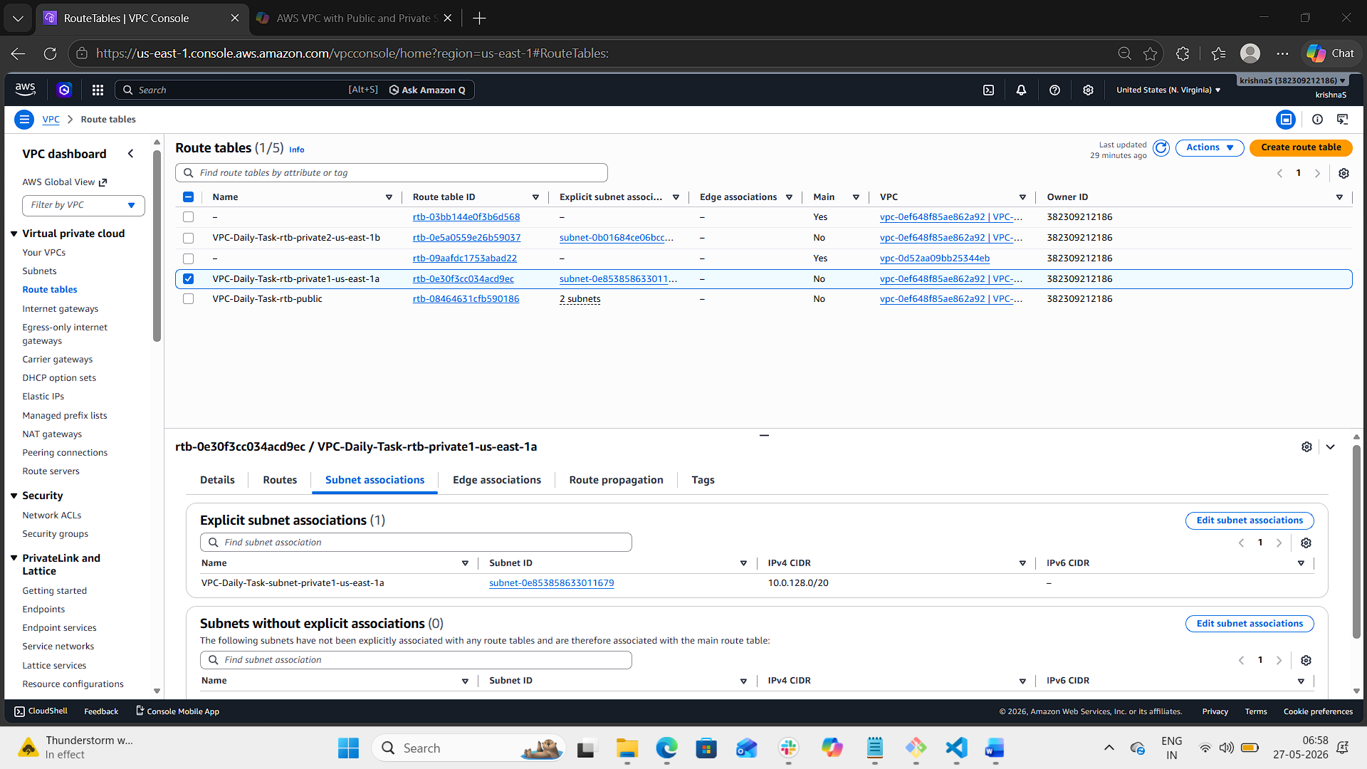
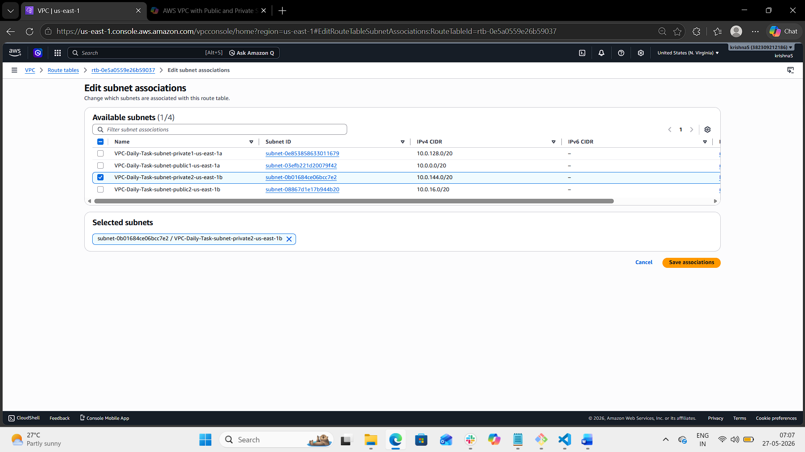

- Add 2 public subnets in public route table.
- Login to aws console.
- Enter VPC dashboard.
- Navigate to route tables page.
- Select VPC-Daily-Task-rtb-public
- Navigate to subnet associations.
- Click on edit subnet associations.
- Select both the public subnets.
- Click on save button.
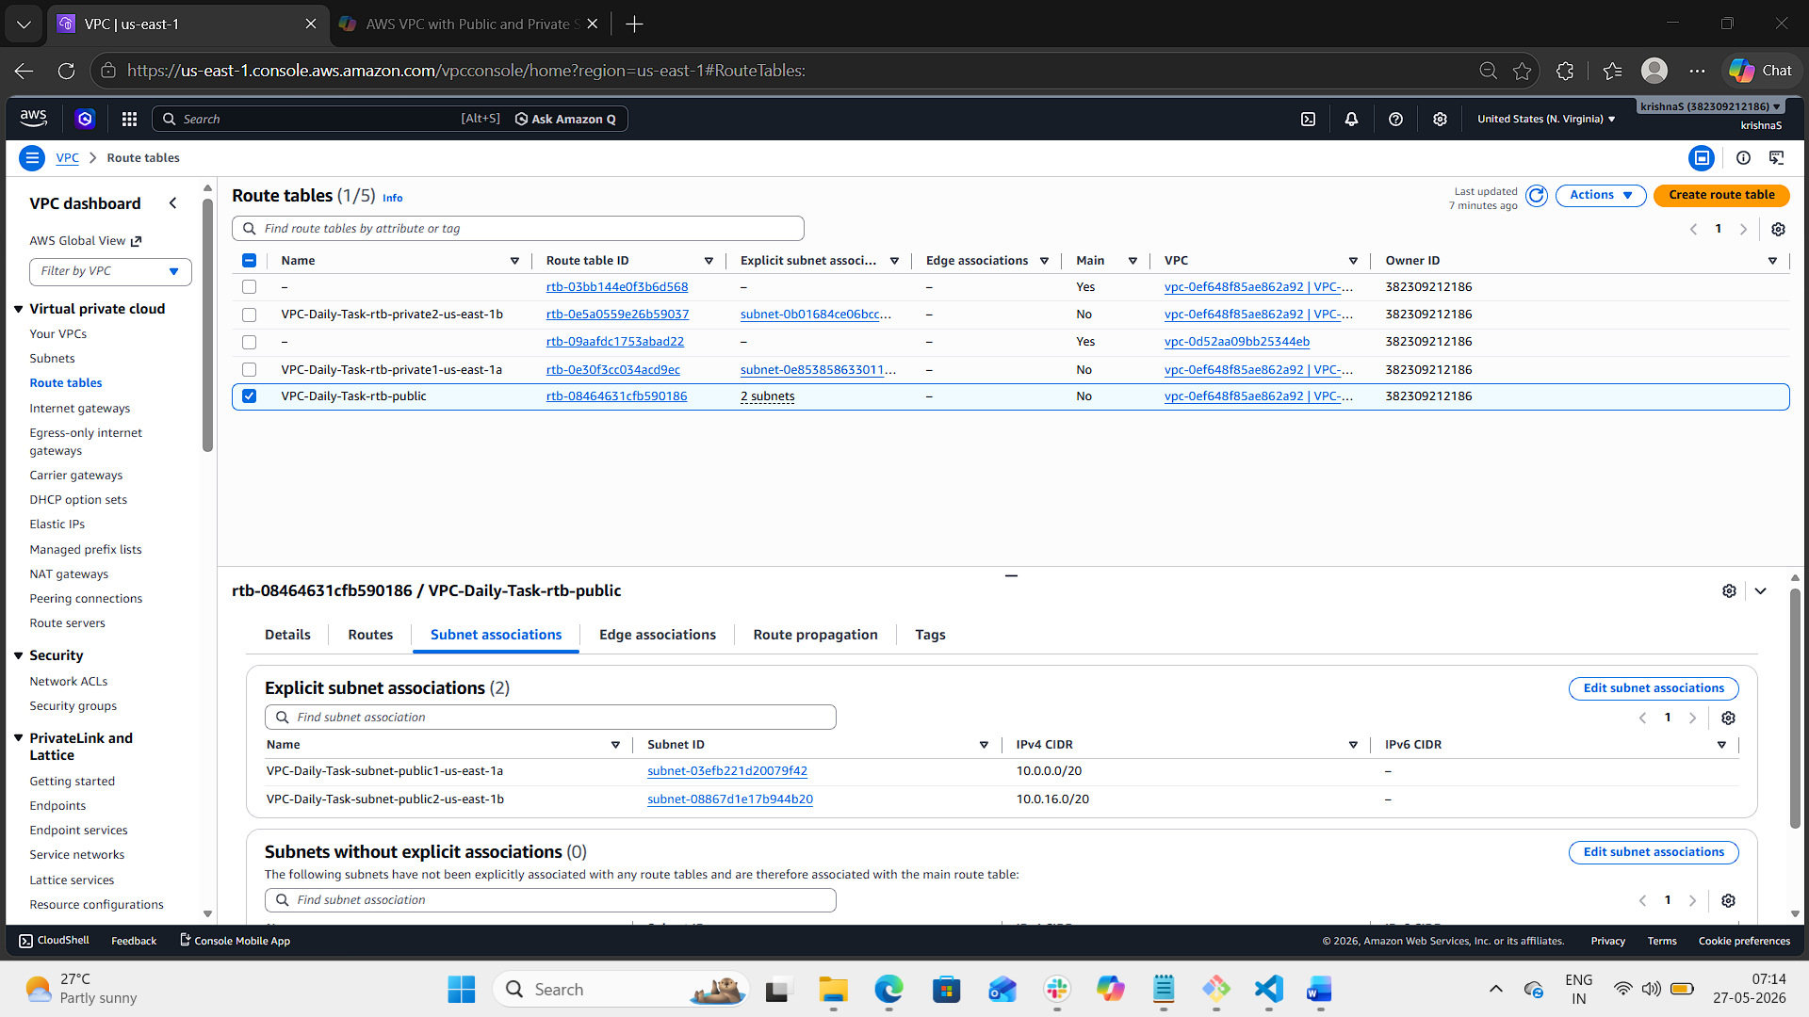
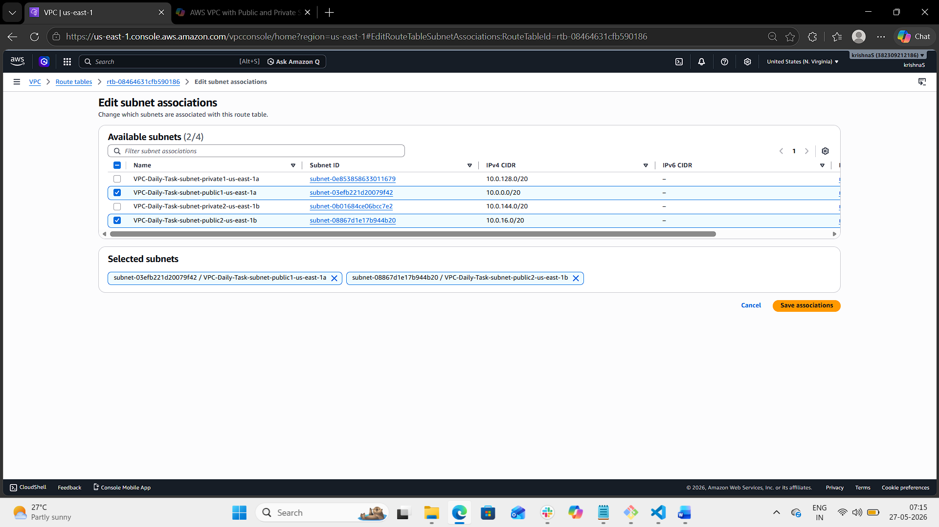
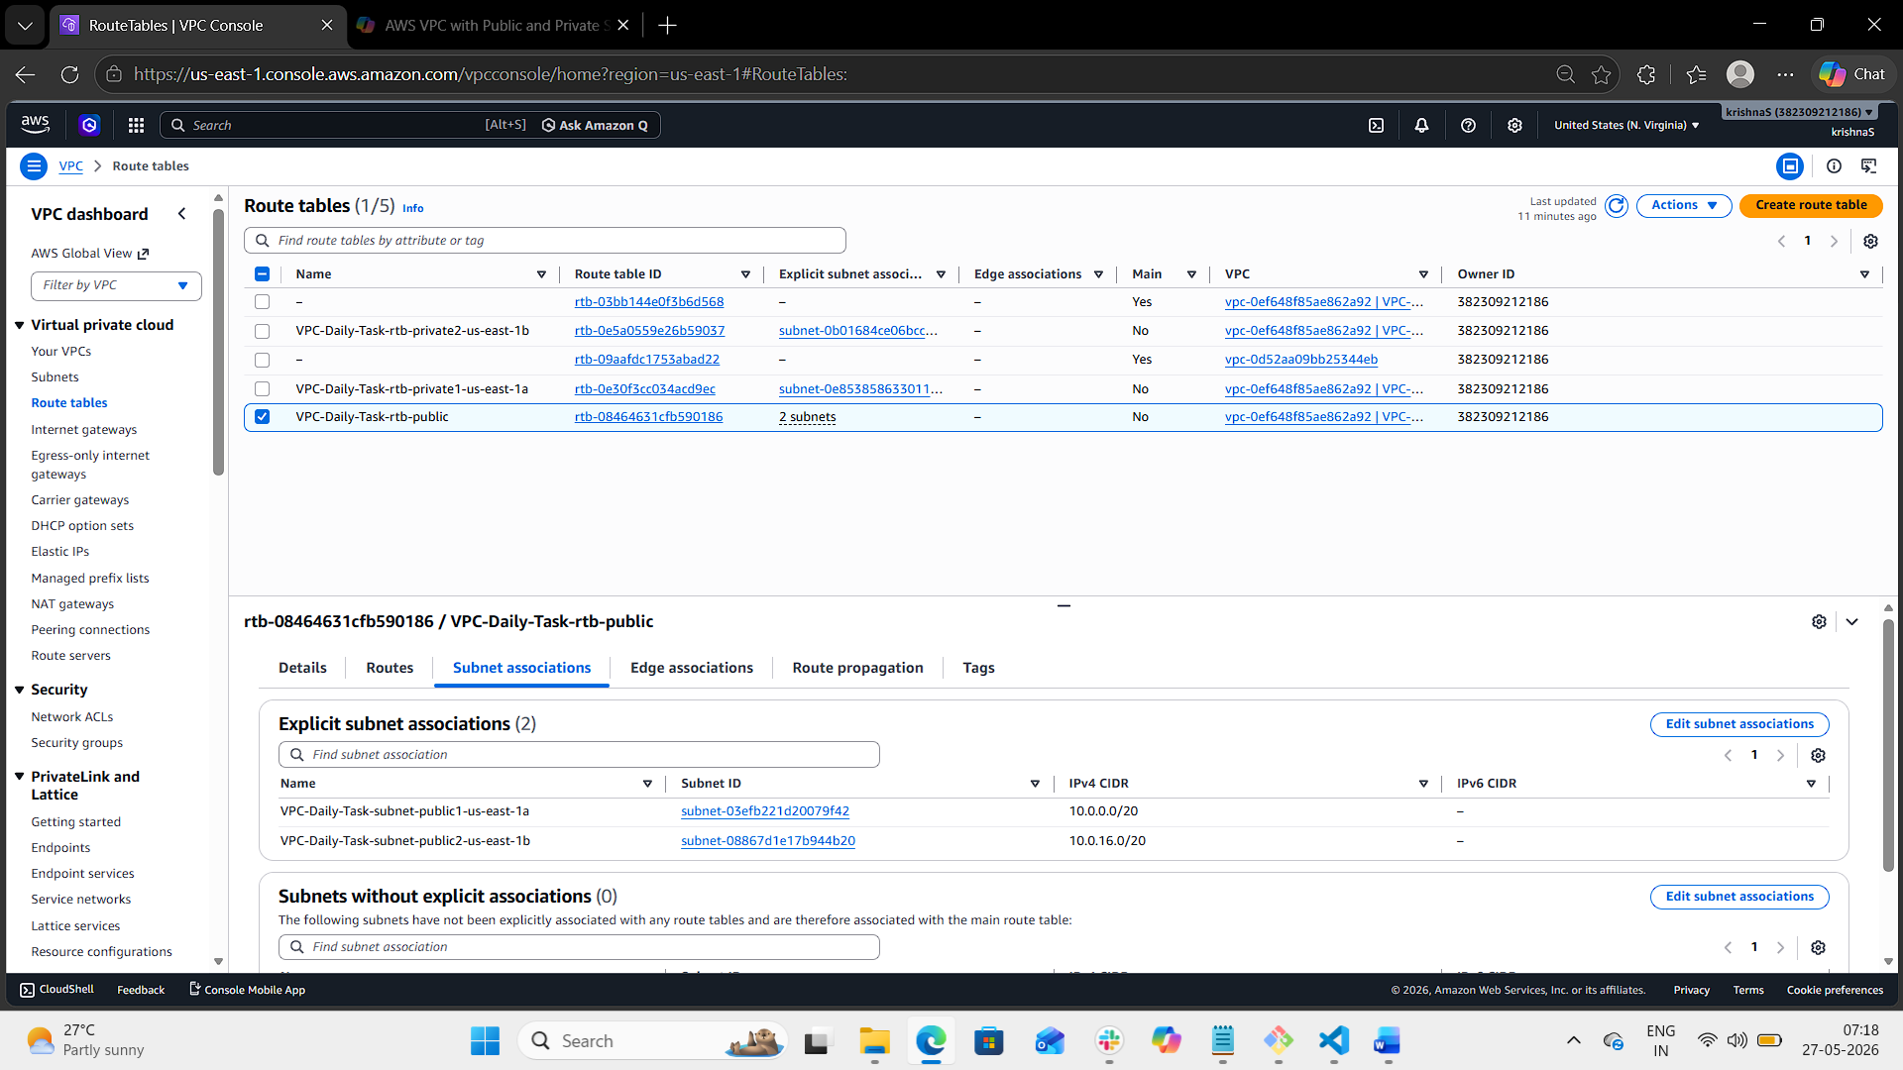
- Public route table will have the routes to internet and local.
- Login to aws console.
- Enter VPC dashboard.
- Navigate to route tables page.
- Select VPC-Daily-Task-rtb-public
- Switch to route tab.
- Notice the existing routes.
- Aws automatically creates local routes
- To add internet route click on edit routes
- Add route
- Destination: 0.0.0.0/0 target: IGW
- Click on save changes.
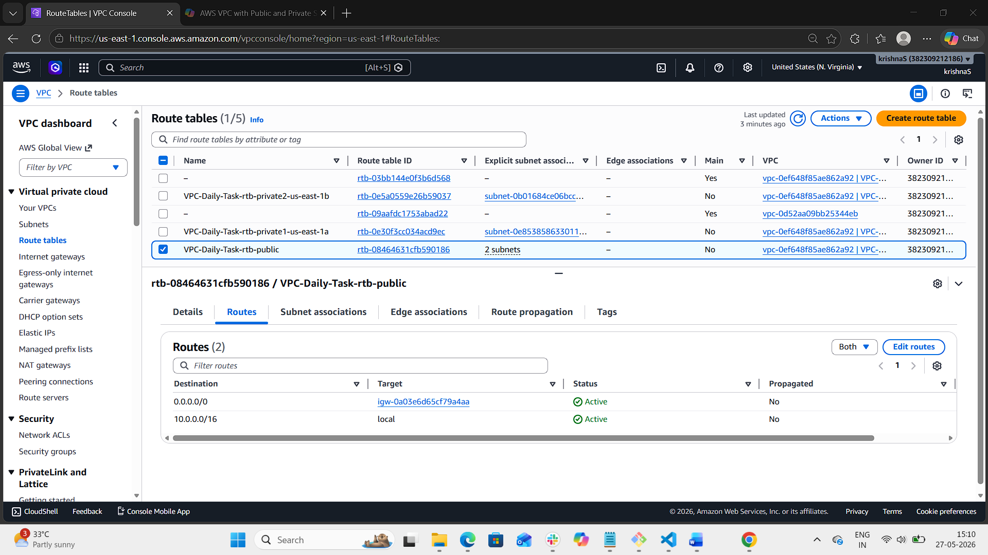
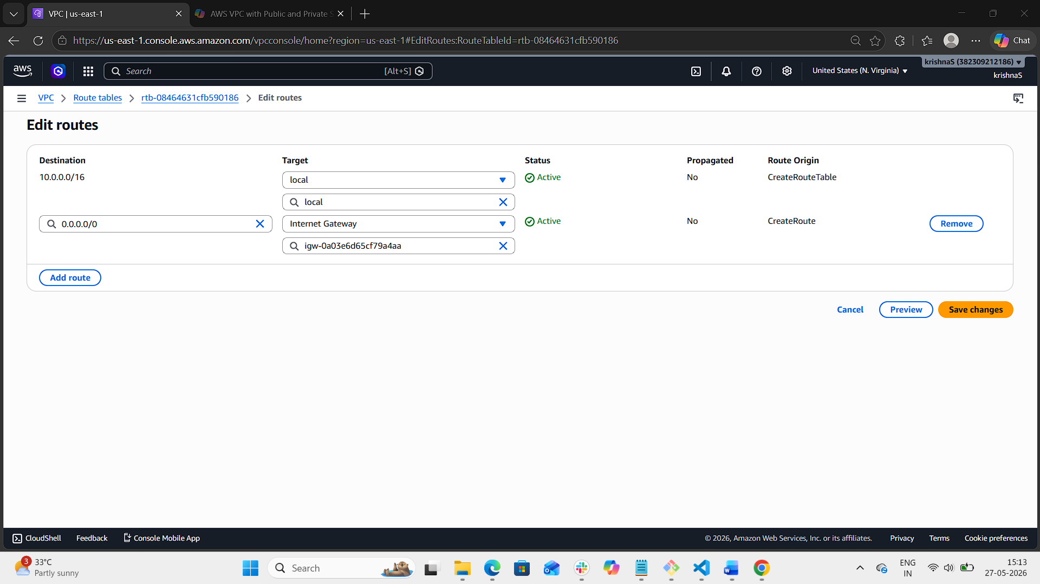

- Create EC2 in public subnet with t2.micro and install PHP.
- Login to aws console.
- Navigate to EC2 instance
- Launch an instance
- Configure instance with key pair, network settings, security groups
- Click on launch instance.
- Go to instance page.
- Select php-instance and navigate to instance summary.
- Click on connect button.
- Connect to the browser based terminal.
- Update system using: sudo yum update -y
- Install httpd: sudo you install httpd -y
- Sudo Systemctl start httpd
- Sudo systemctl enable httpd
- Sudo systemctl status httpd
- Sudo dnf install php php-cli php-mysqlnd -y
- rub php -v to verify if php is installed.
- Echo ‘<?php phpinfo();?>’ | sudo tee /var/www/html/info.php
- Open browser and enter: http://<EC2-public-IP>/info.php

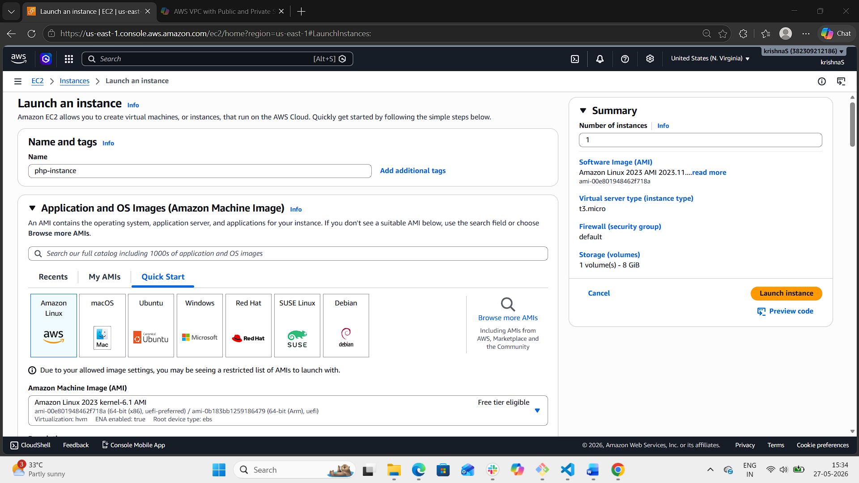
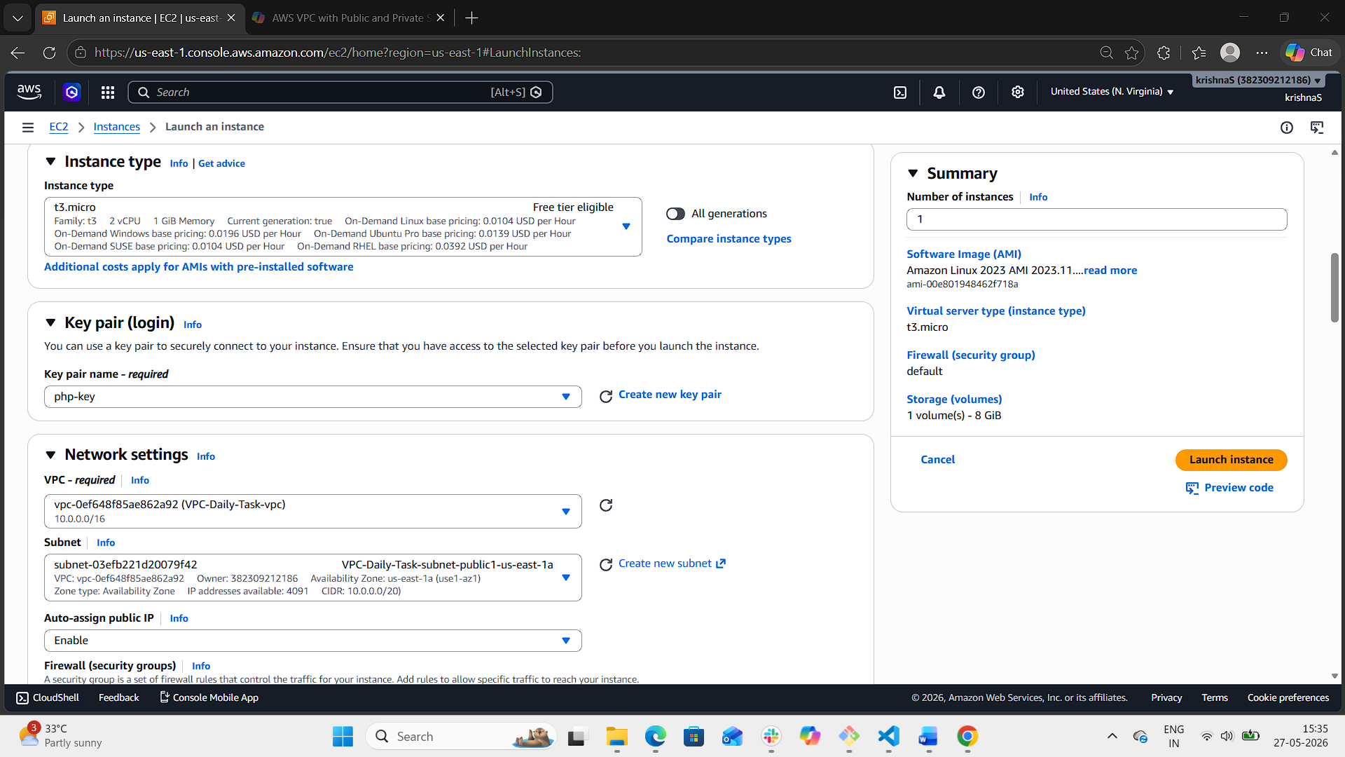
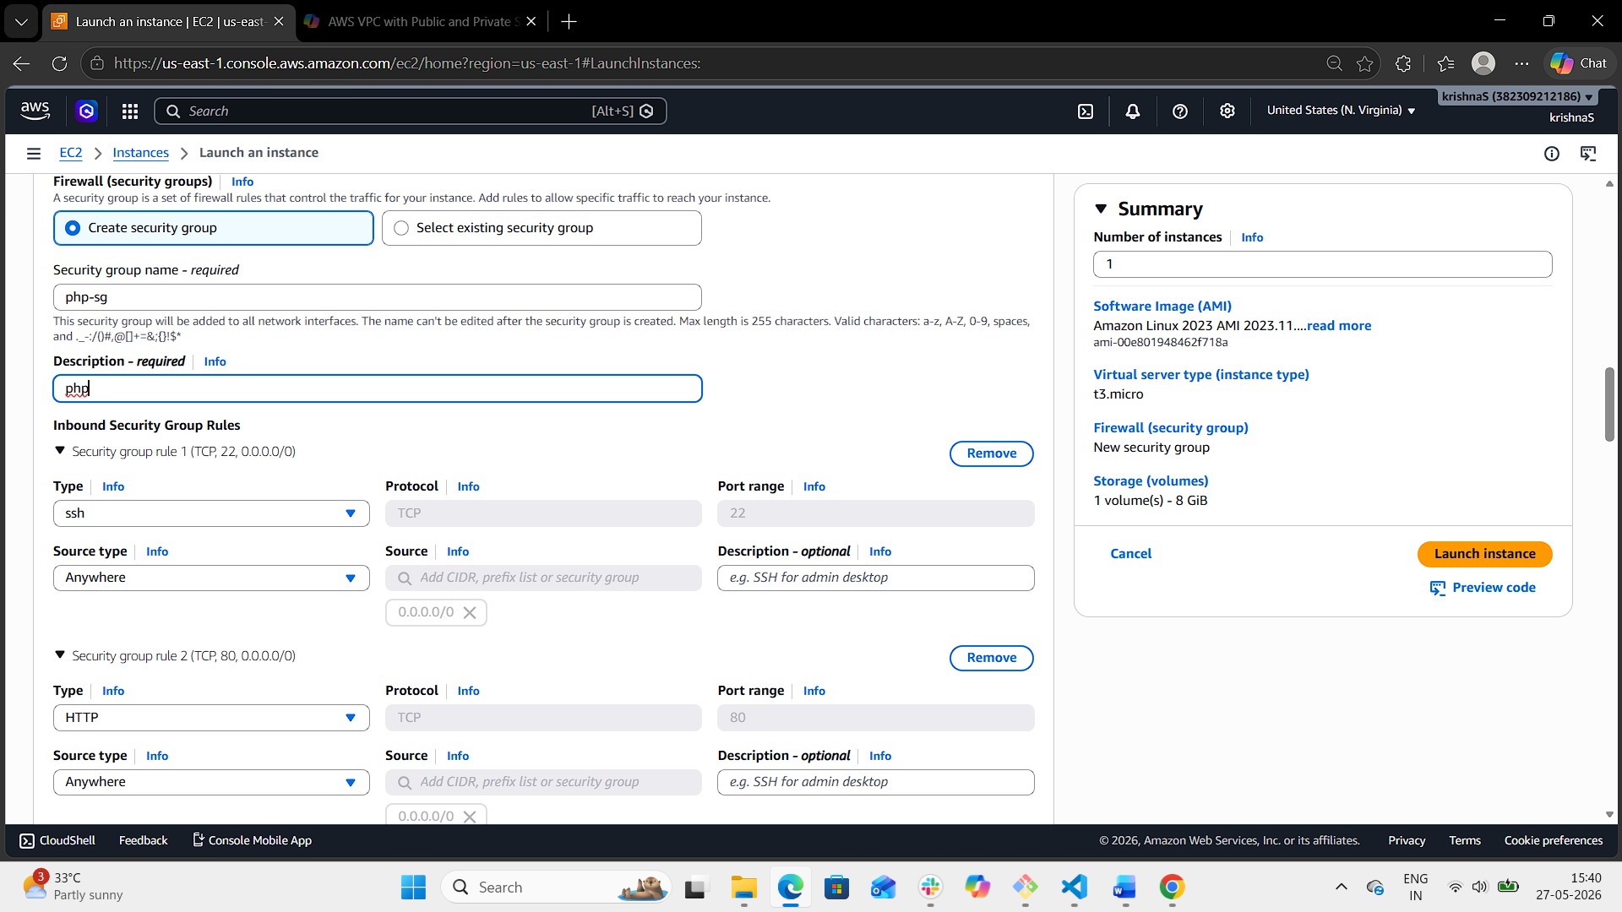
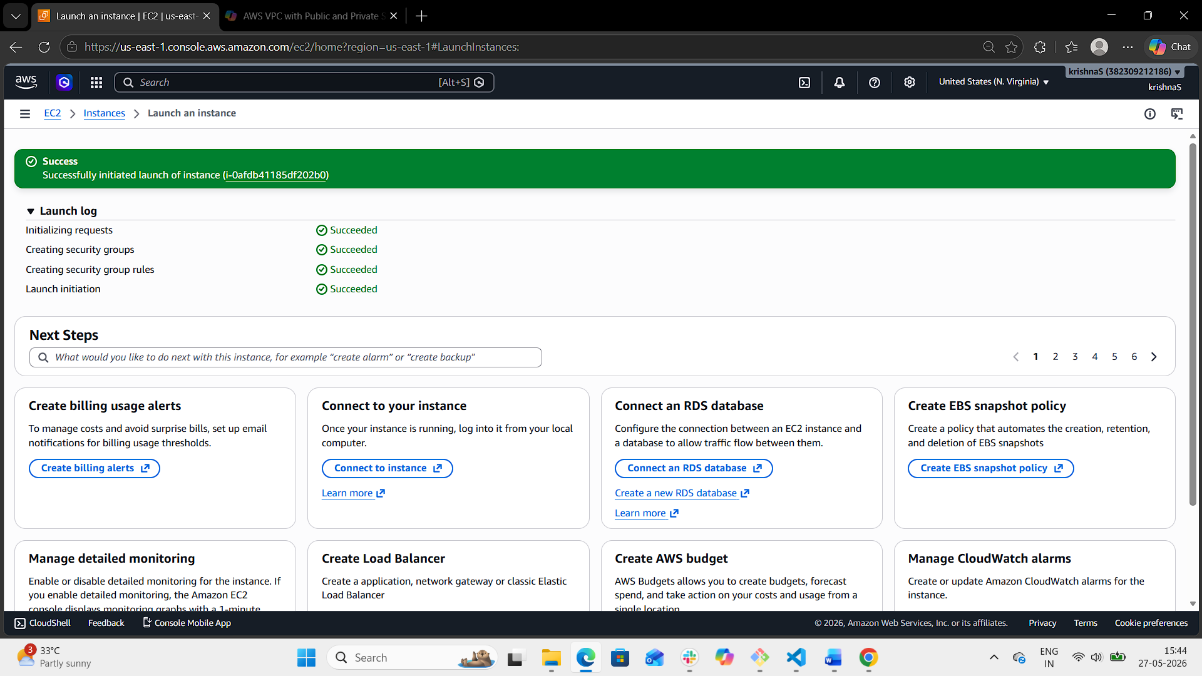
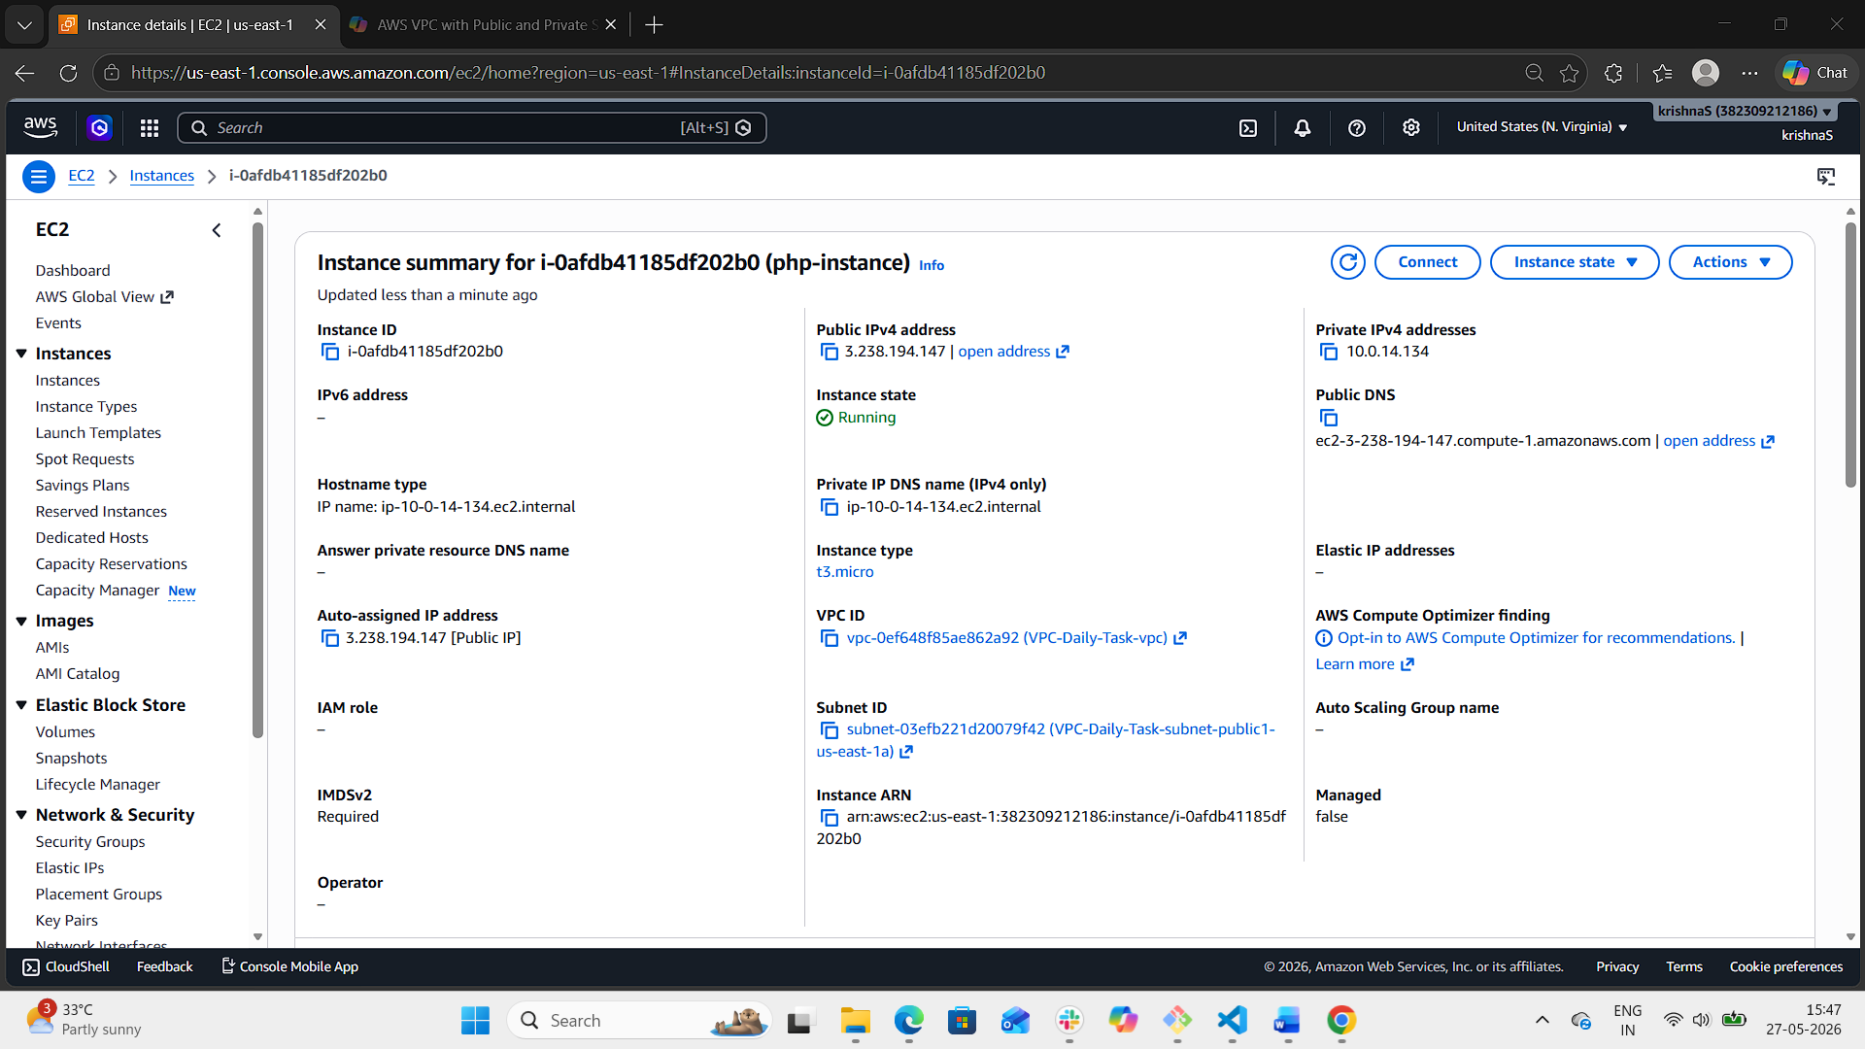
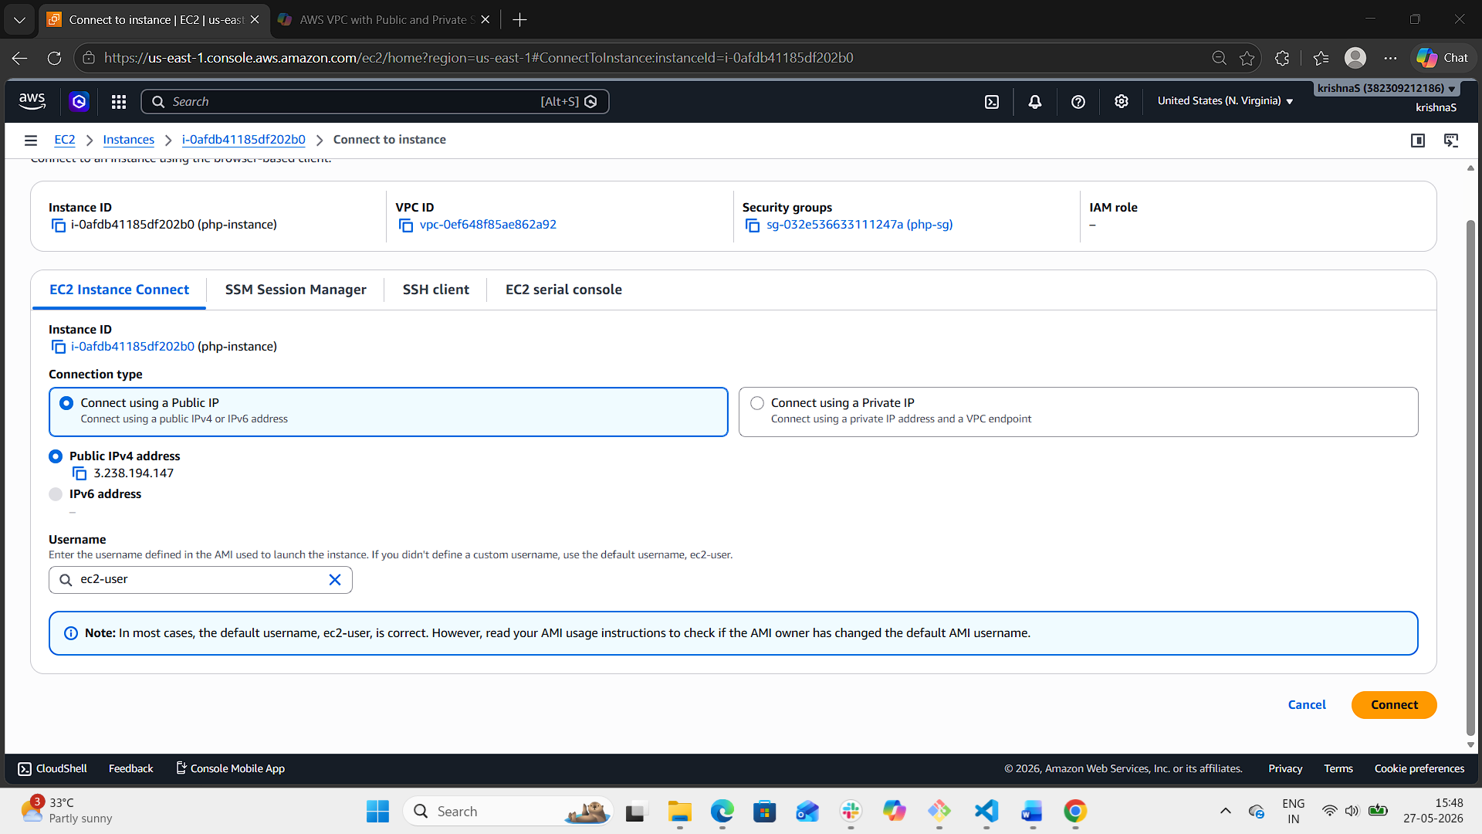
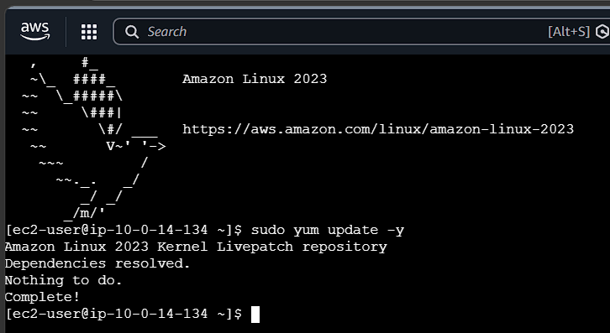
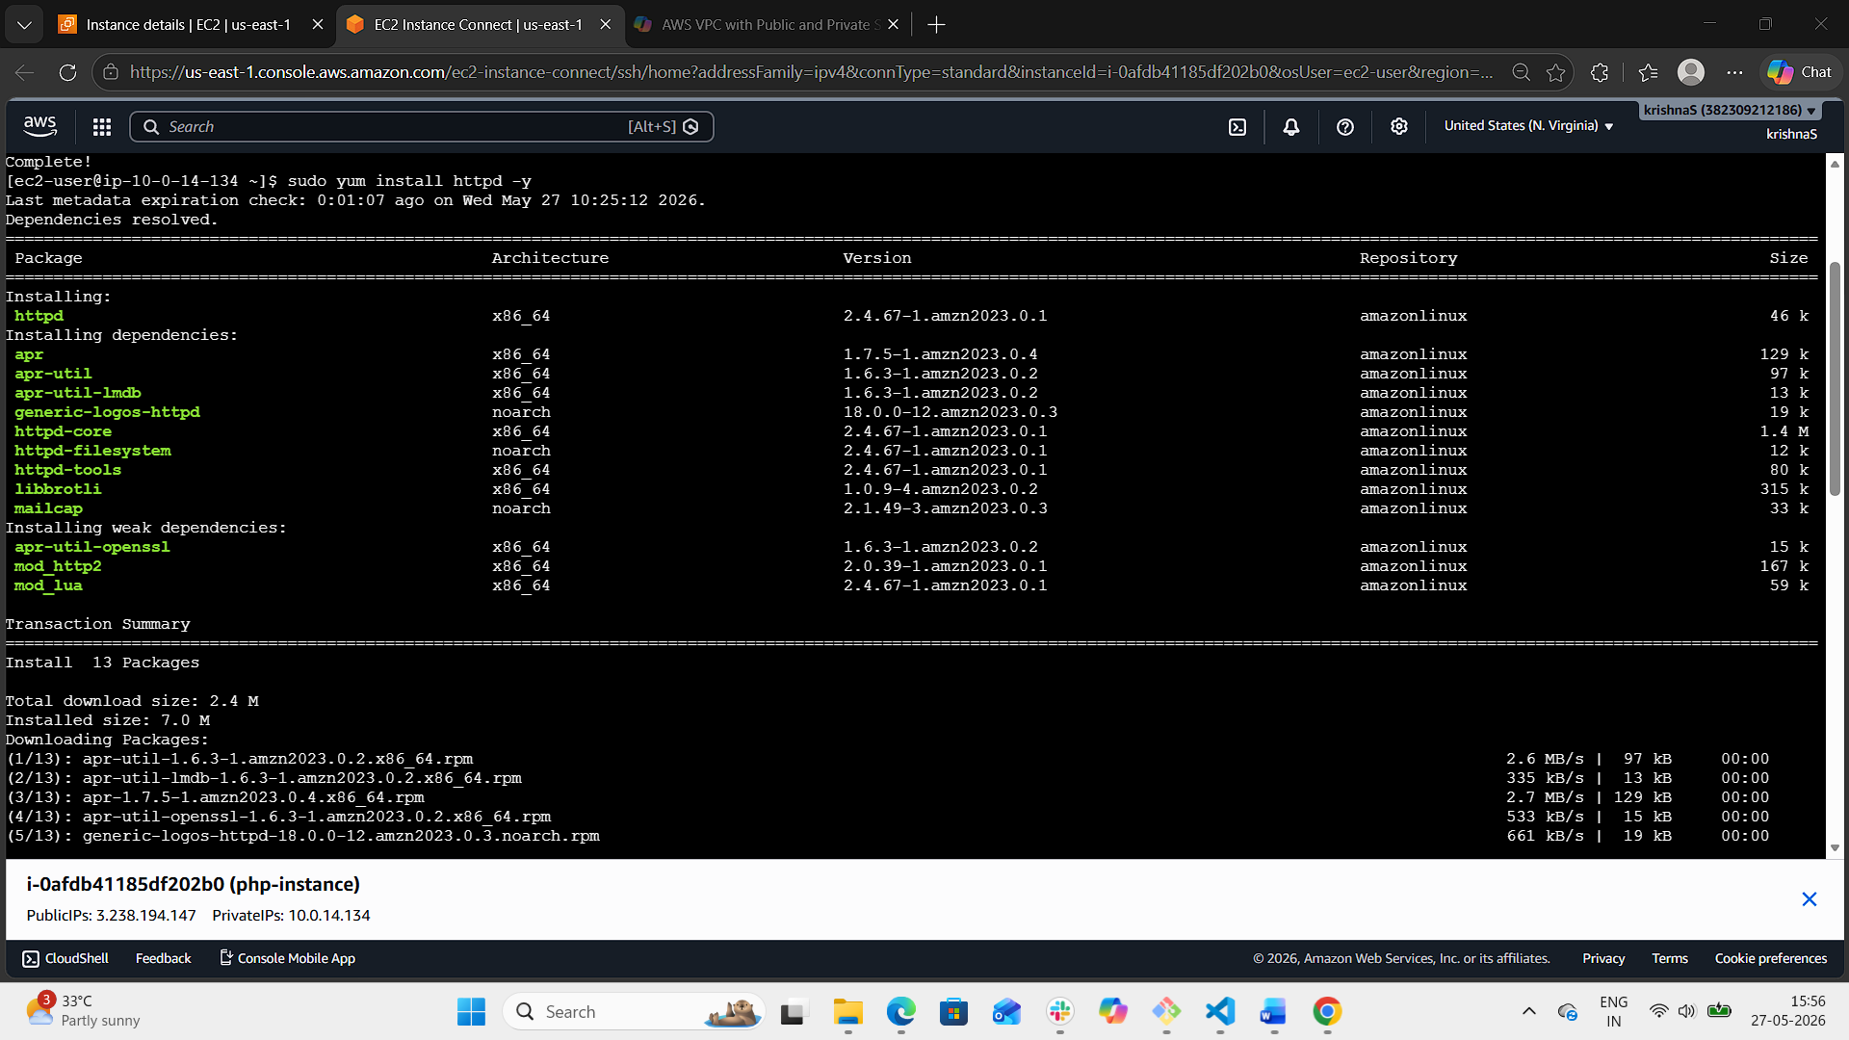
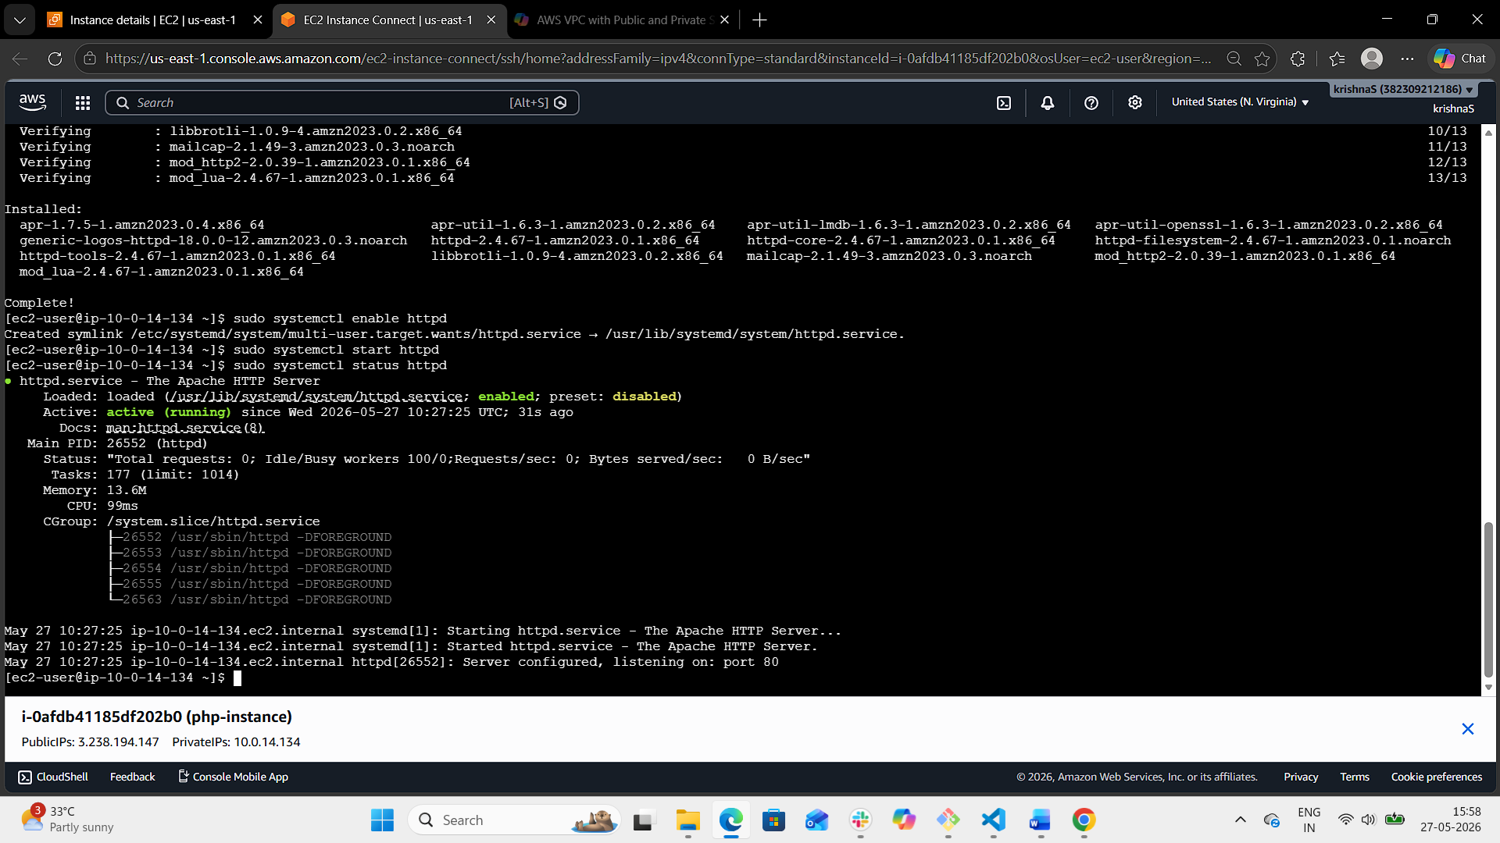
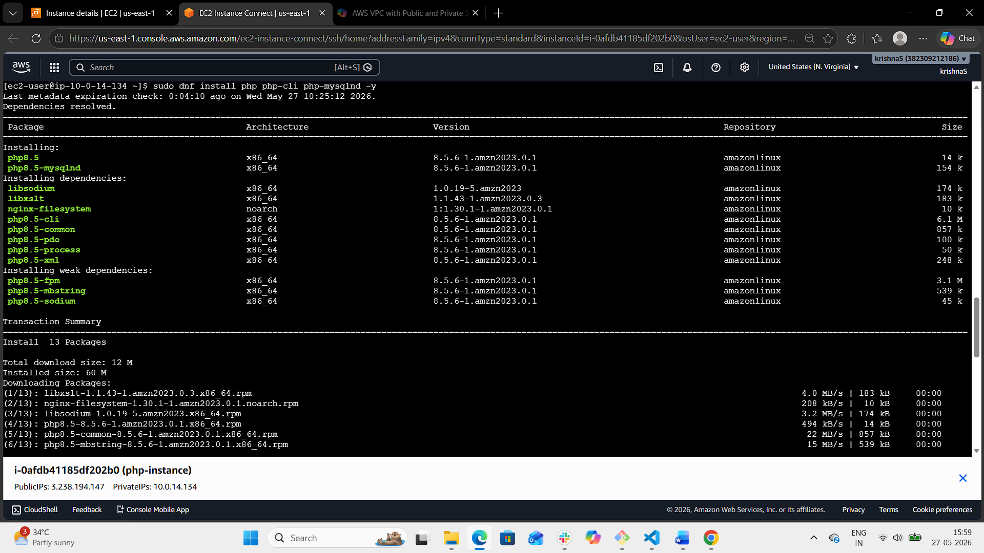
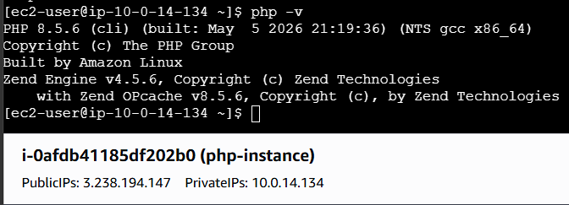
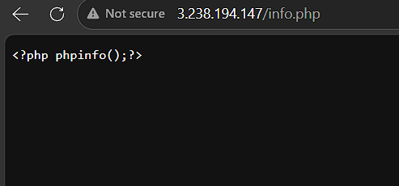
- Configure NAT gateway in public subnet and connect to private instance.
- Login to aws console.
- Navigate to VPC
- Click on elastic IP from the left navigation panel
- Click on Allocate an elastic IP
- Click on allocate.
- Navigate to NAT gateway
- Click Create NAT gateway
- Configure NAT gateway with vpc and elastic IP
- Click on Create NAT gateway
- Wait until ip address is displayed and status is succeeded
- Navigate to route tables to configure private route tables
- Select a private route table.
- Open route tab
- Click on edit route
- Configure NAT gateway with 0.0.0.0/0
- Select the created nat gateway
- Click on save changes
- Repeat same steps for another private route table.
- Now connect to the public EC2 instance
- ssh -i keys.pem ec2-user@ 44.204.77.215 <public IP>
- now connect to the private instance from the above public instance (which is bastion server)
- ssh -i keys.pem ec2-user@ 10.0.144.104 <private IP>
- after the connection use: ping google.com
- hence the connection is established with the public instance using NAT gateway.

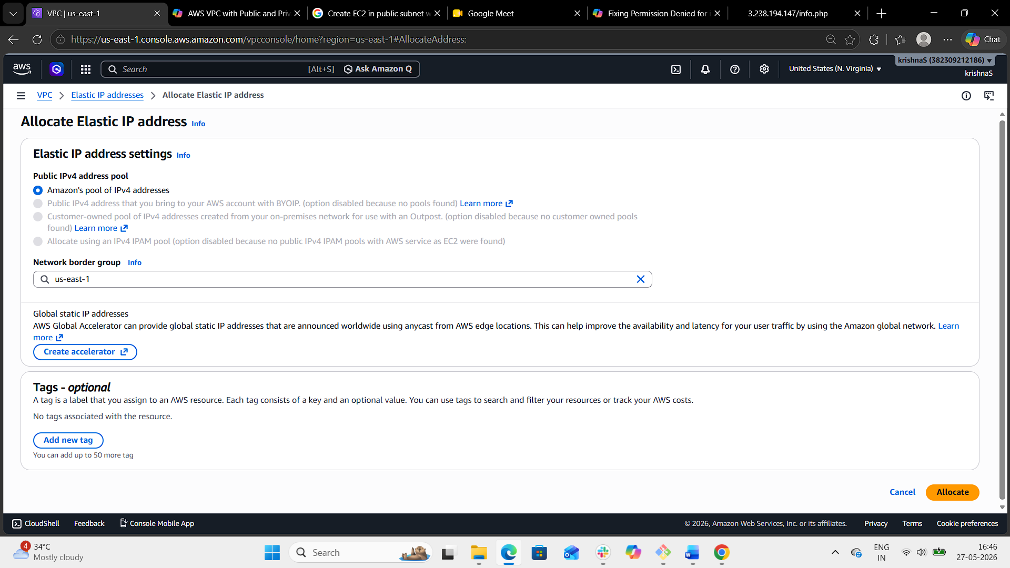
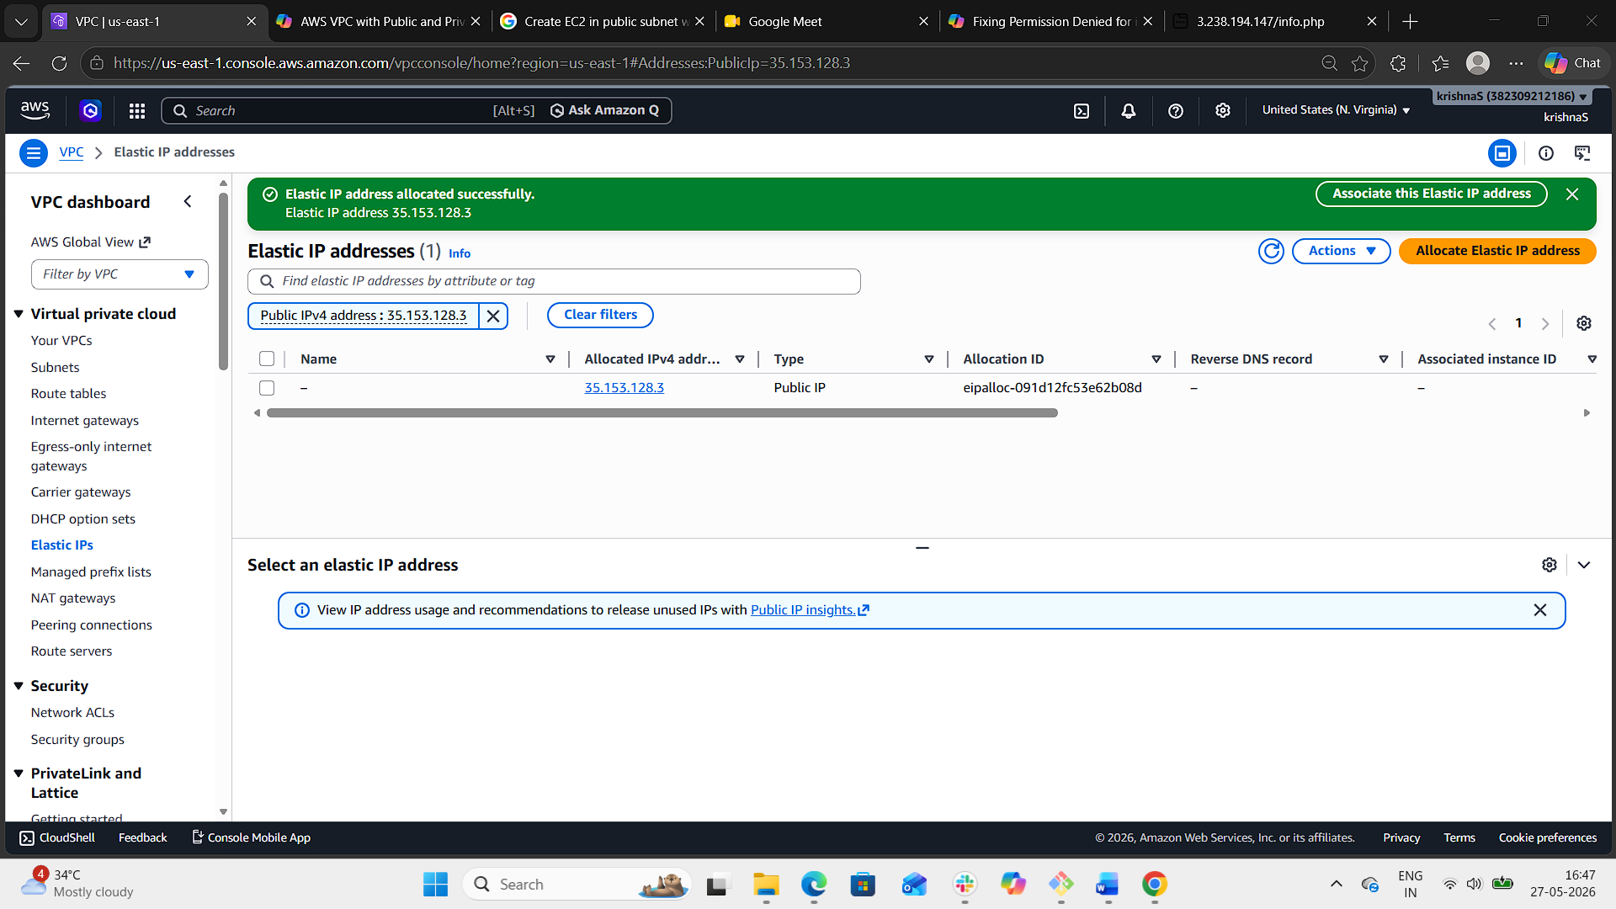
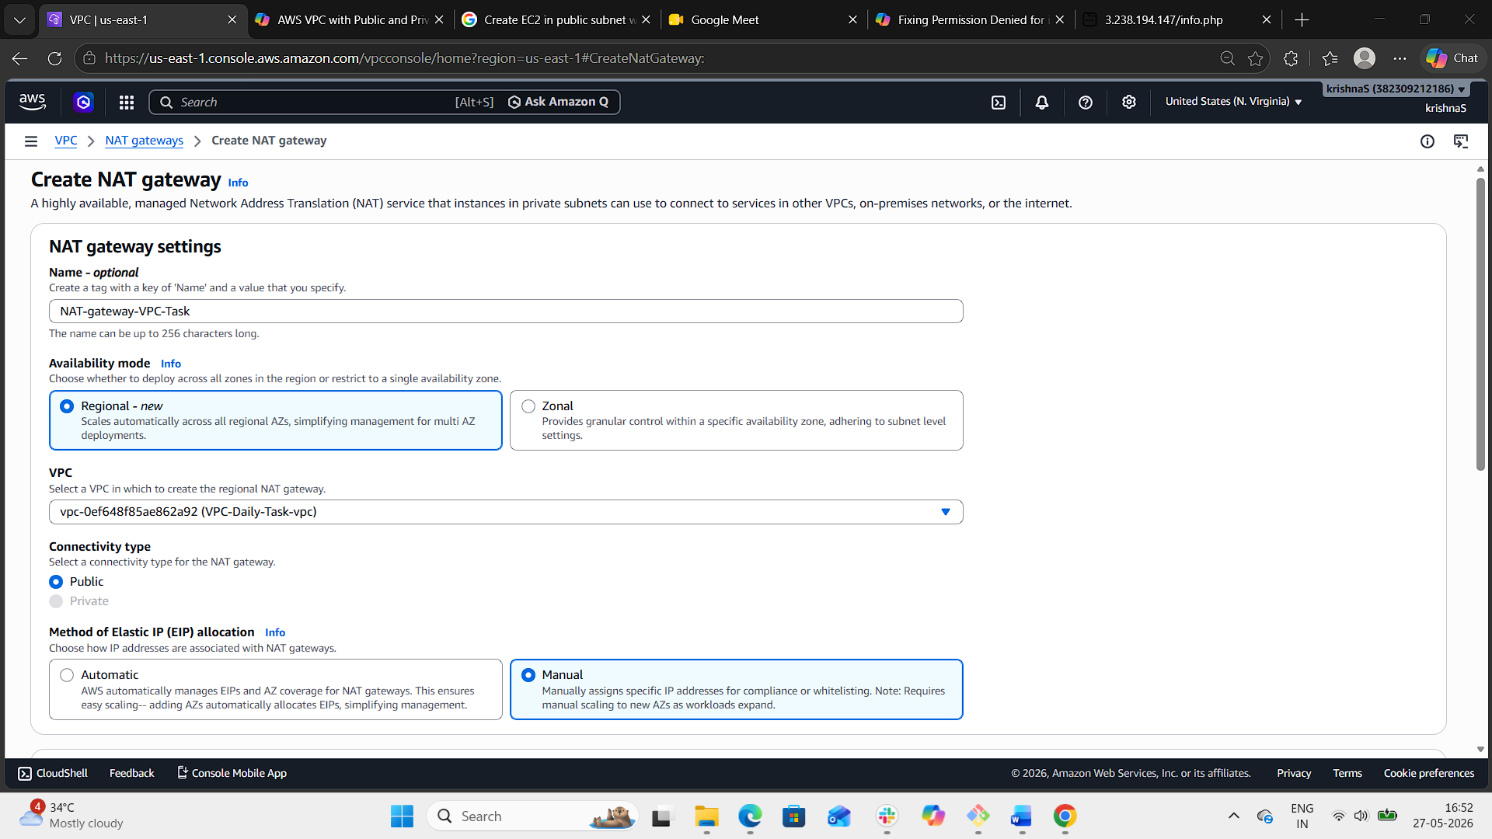
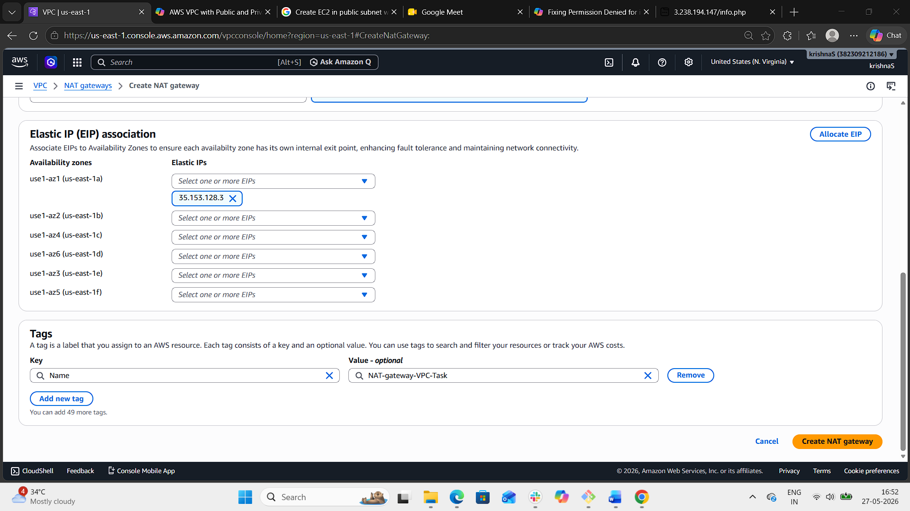
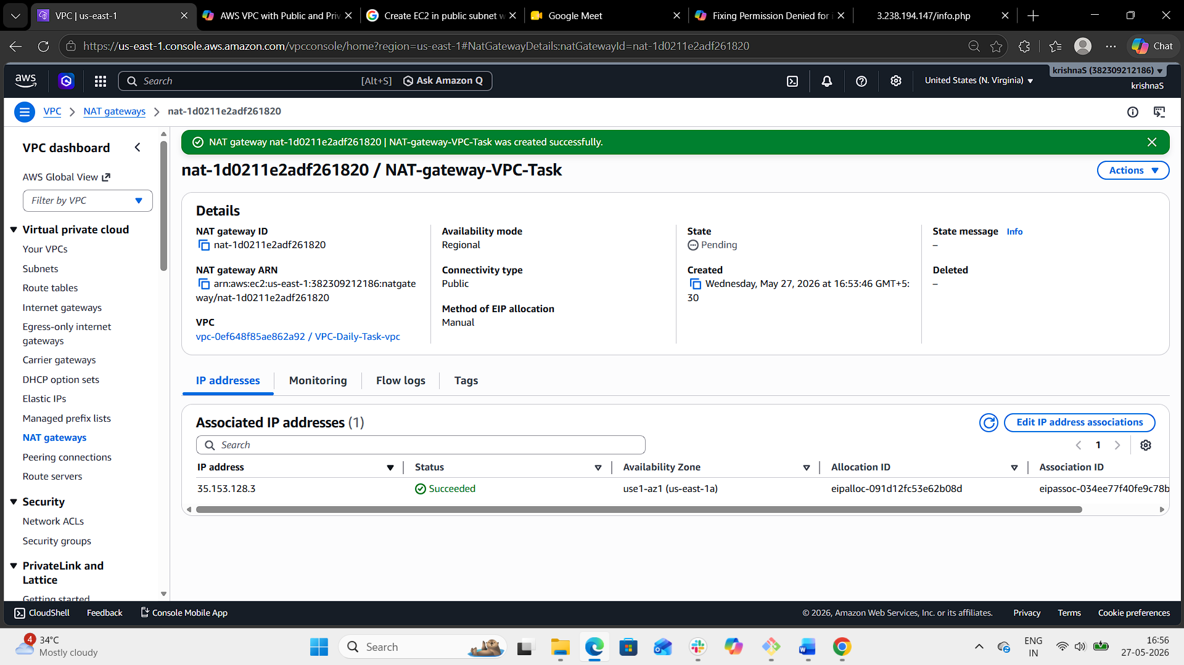
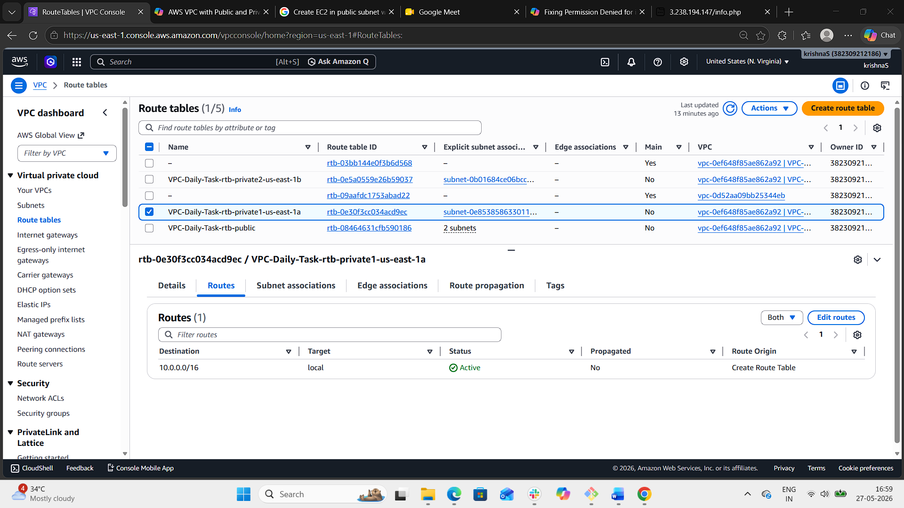
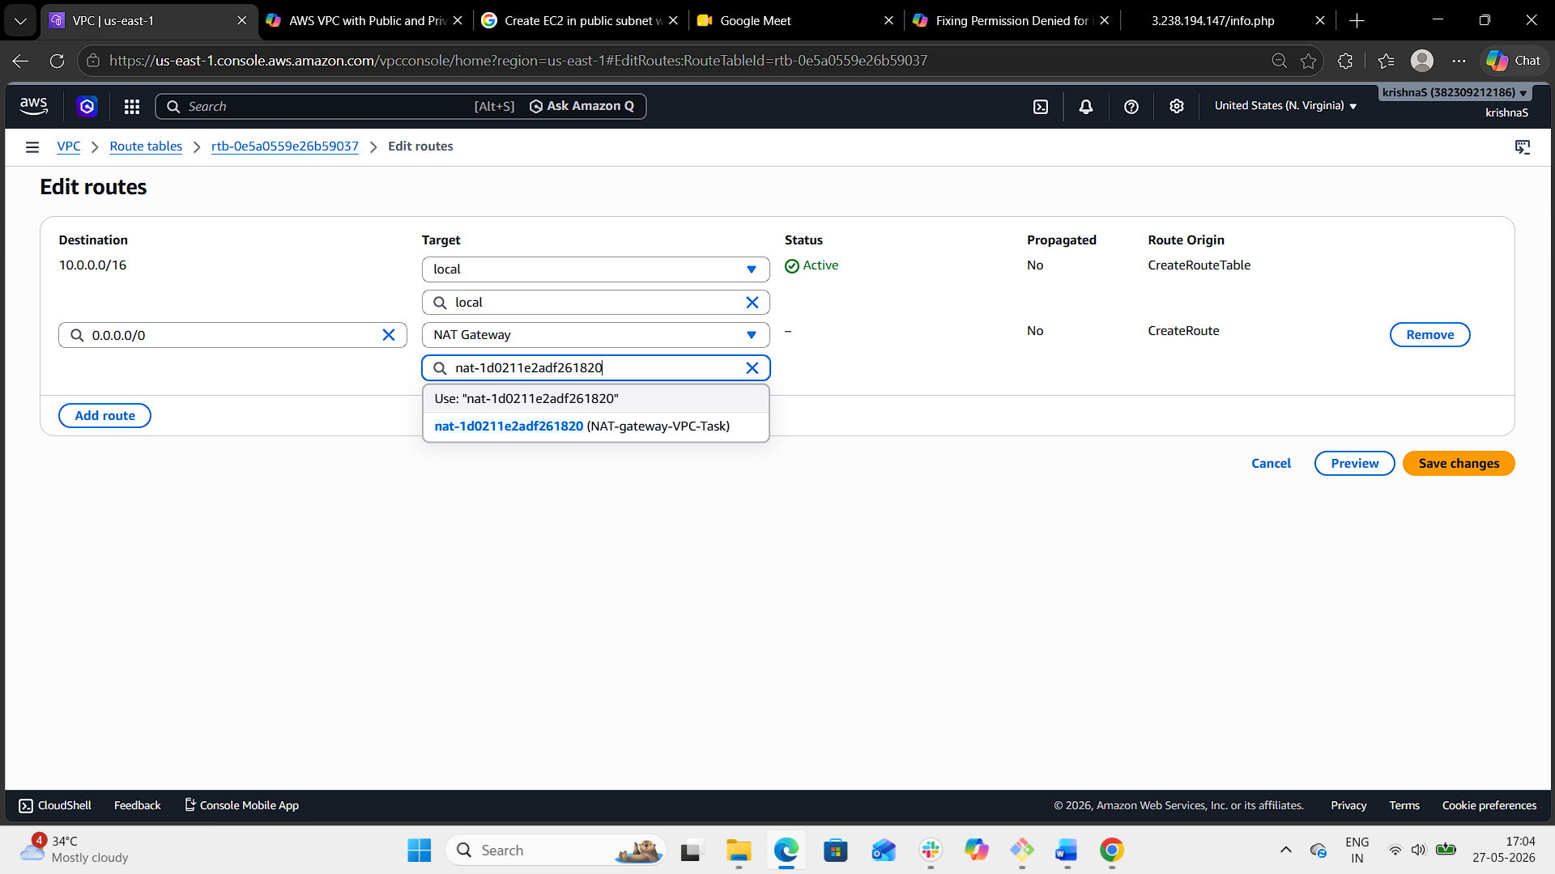
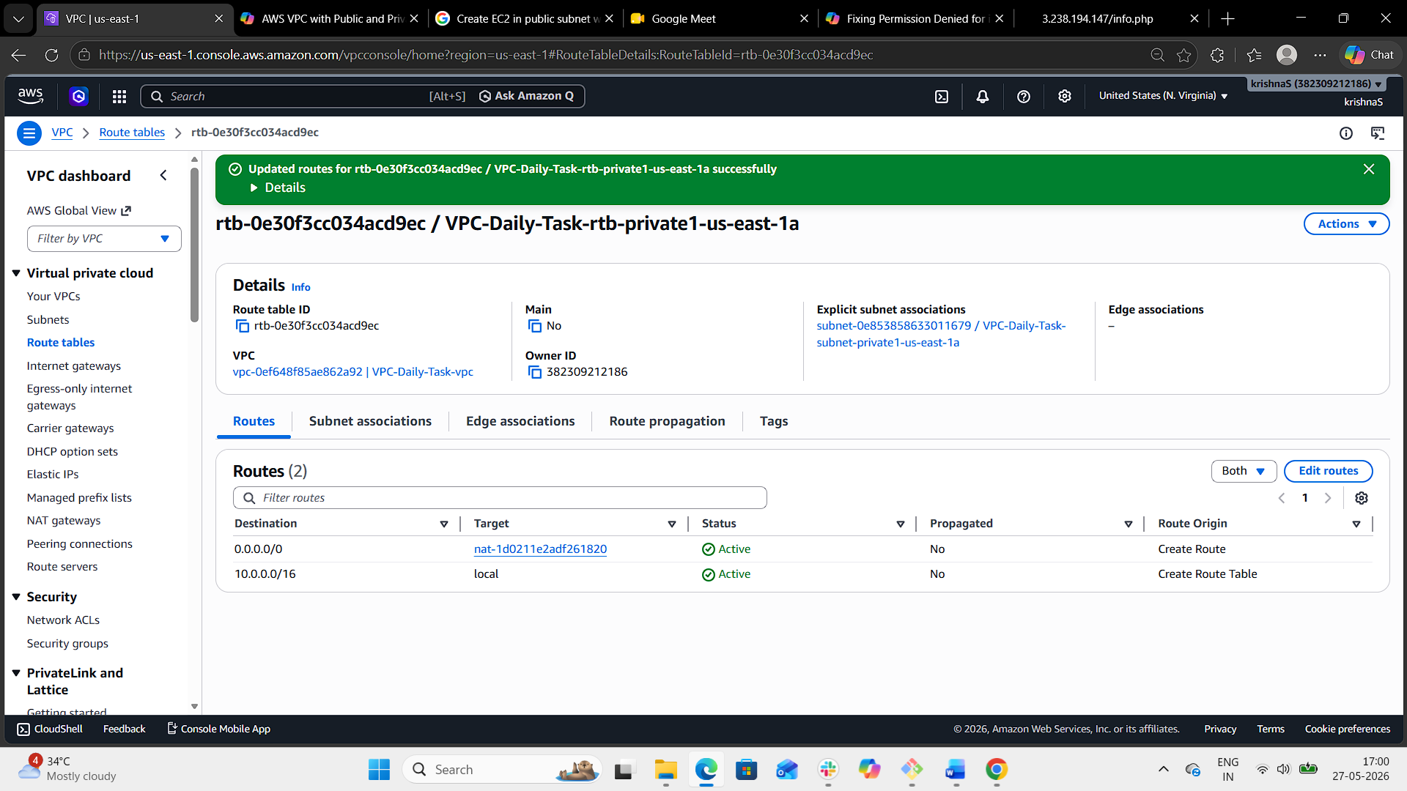
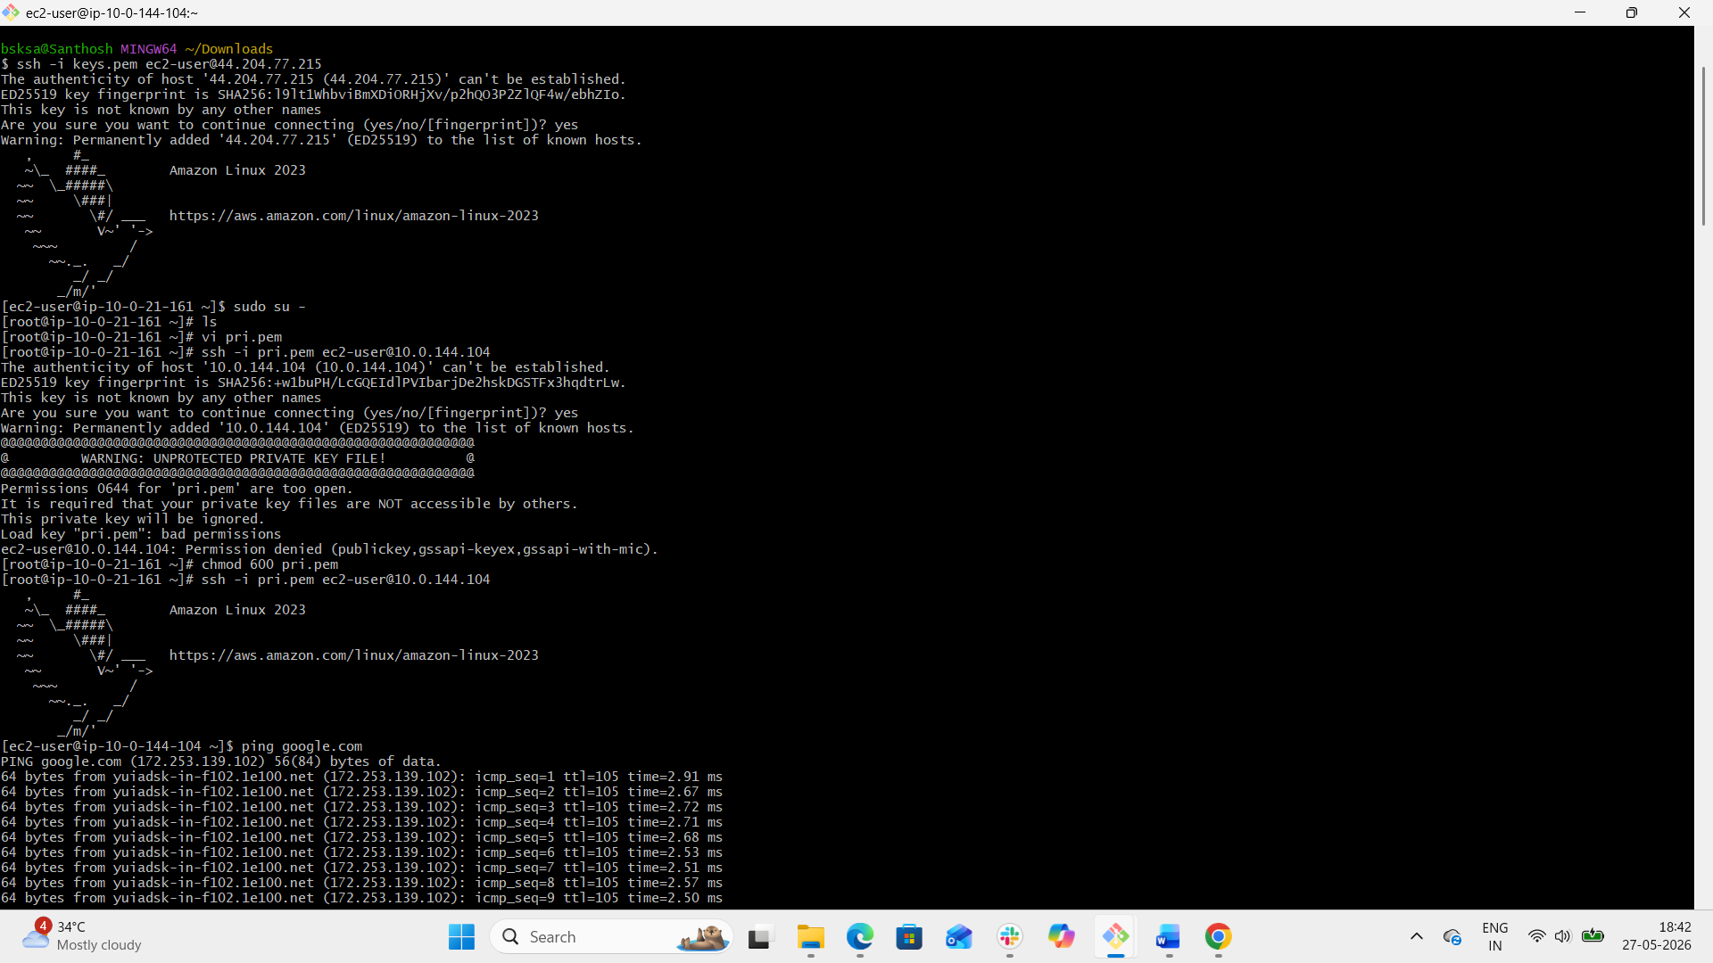

- Install Apache Tomcat in private EC2 and deploy a sample app.
- Login to aws site.
- Start public and private instance.
- Now connect to the public EC2 instance from git bash
- ssh -i keys.pem ec2-user@ 44.204.77.215 <public IP>
- now connect to the private instance from the above public instance (which is bastion server)
- ssh -i keys.pem ec2-user@ 10.0.144.104 <private IP>
- after the connection use: ping google.com
- hence the connection is established with the public instance using NAT gateway.
- Update system packages: sudo yum update -y
- Install java version 21: sudo you install java-21 -y
- Java - -version to check if java installed properly or not.
- Change the directory to tmp
- Download tomcat using : wget https://dlcdn.apache.org/tomcat/tomcat-9/v9.0.118/bin/apache-tomcat-9.0.118.tar.gz
- Extract the downloaded tomcat file: tar xvf apache-tomcat-9.0118.tar.gz
- Move the file to /opt/tomcat: mv apache-tomcat-9.0.118 /opt/tomcat
- Give executable permissions to startup.sh file: sudo chmod +x /opt/tomcat/bin/*.sh
- Run the startup.sh file: /opt/tomcat/bin/startup.sh
- Notice that the tomcat service is started.
- Open the private EC2 Security Group and add inbound rules.
- Navigate to webapps directory: cd /opt/tomcat/webapps
- Create sample application directory: sudo mkdir sampleapp
- Create sample JSP page: echo "<h1>hello Apache Tomcat 9 Application server is Deployed Successfully</h1>" | sudo tee /opt/tomcat/webapps/sampleapp/index.jsp
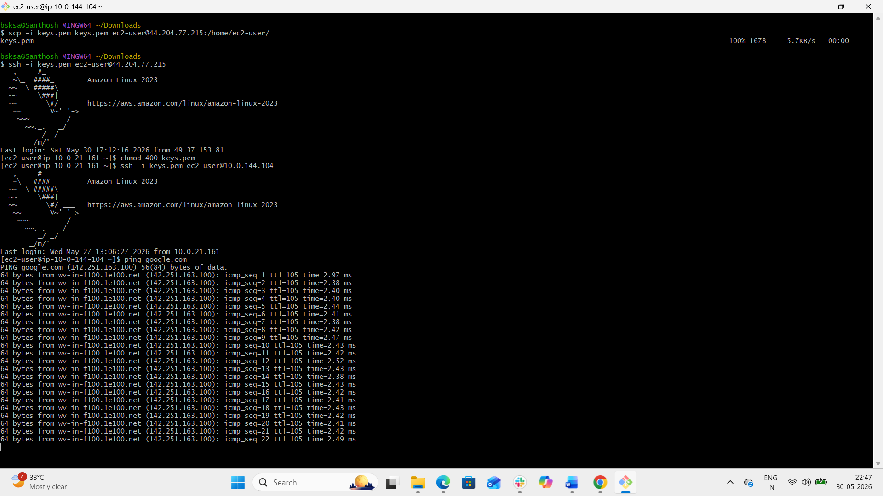
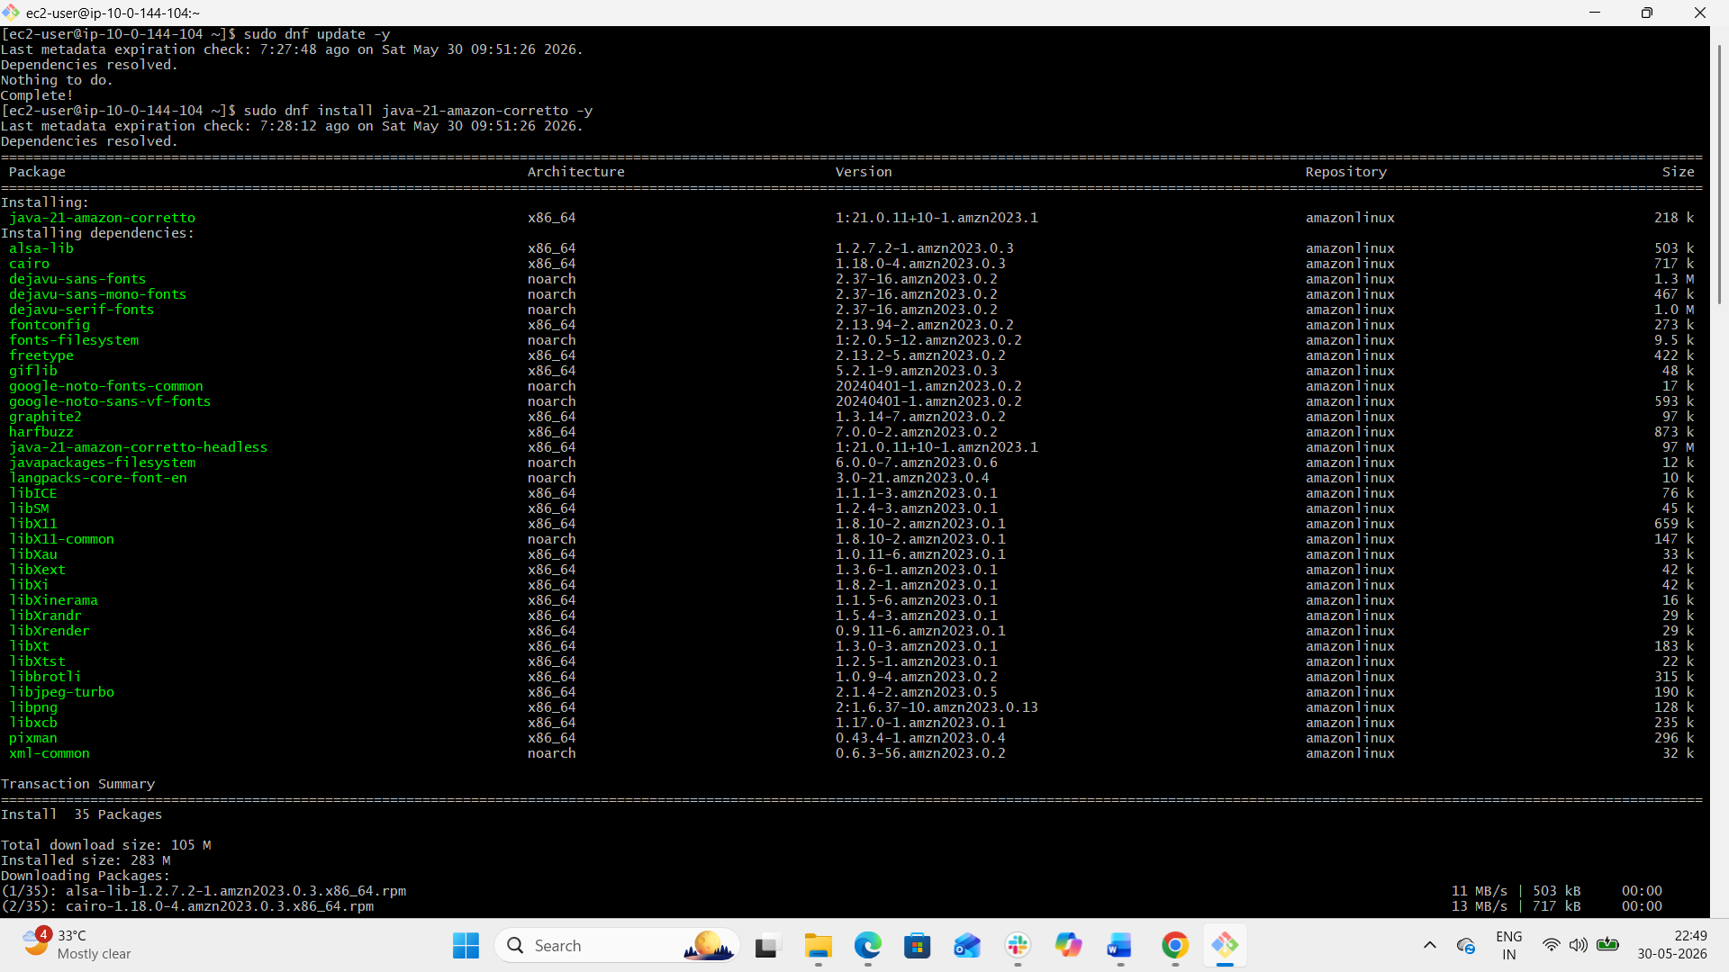
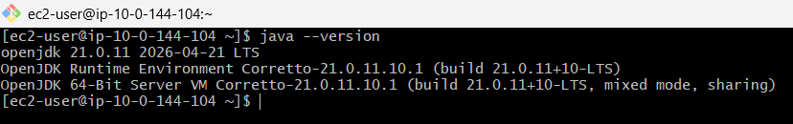
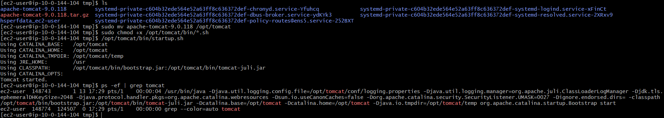

- Configure VPC flow logs and store the logs in S3 and CloudWatch.
- Navigate to CloudWatch → Logs → Log groups
- Click on Create log group
- Enter Log Group Name: vpc-flowlog-cloudwatch
- Click Create.
- Navigate to S3 bucket and click on Create bucket
- Enter Bucket Name as vpc-flowlog.
- Click on create bucket.
- Notice that the S3 bucket created successfully.
- Now navigate to IAM service and switch to roles section.
- Click on Create role
- Select Trusted entity: AWS Service and Use case: VPC Flow Logs.
- Attach permissions with CloudWatchLogsFullAccess
- Click on Next and Create role with role name as vpcflowlog-role
- Notice that IAM role created successfully.
- Go to VPC service and select Your VPCs
- Select VPC-Daily-Task-vpc
- Switch to Flow logs tab
- Click on Create flow log
- Configure:
Setting | Value
Filter | ALL
Destination | CloudWatch Logs
Log Group | vpc-flow-logs
IAM Role | VPCFlowLogsRole
Interval | 1 minute
- Click on create flow log.
- Create a Second Flow Log for S3
- Click on create flow log again
- Configure:
Setting | Value
Filter | ALL
Destination | S3
Bucket ARN | arn:aws:s3:::your-bucket-name
- Click on create flow log.

